

Ministry of Higher Education and Scientific Research
Scientific Supervision and Scientific Evaluation Apparatus
Directorate of Quality Assurance and Academic Accreditation
Accreditation Department




Academic Program and Course Description Guide Academic Program and Course Description Guide
Academic Program and Course Description Guide

2024
Introduction:
The educational program is a well-planned set of courses that include procedures and experiences arranged in the form of an academic syllabus. Its main goal is to improve and build graduates' skills so they are ready for the job market. The program is reviewed and evaluated every year through internal or external audit procedures and programs like the External Examiner Program.
The academic program description is a short summary of the main features of the program and its courses. It shows what skills students are working to develop based on the program's goals. This description is very important because it is the main part of getting the program accredited, and it is written by the teaching staff together under the supervision of scientific committees in the scientific departments.
This guide, in its second version, includes a description of the academic program after updating the subjects and paragraphs of the previous guide in light of the updates and developments of the educational system in Iraq, which included the description of the academic program in its traditional form (annual, quarterly), as well as the adoption of the academic program description circulated according to the letter of the Department of Studies T 3/2906 on 3/5/2023 regarding the programs that adopt the Bologna Process as the basis for their work.
In this regard, we can only emphasize the importance of writing an academic programs and course description to ensure the proper functioning of the educational process

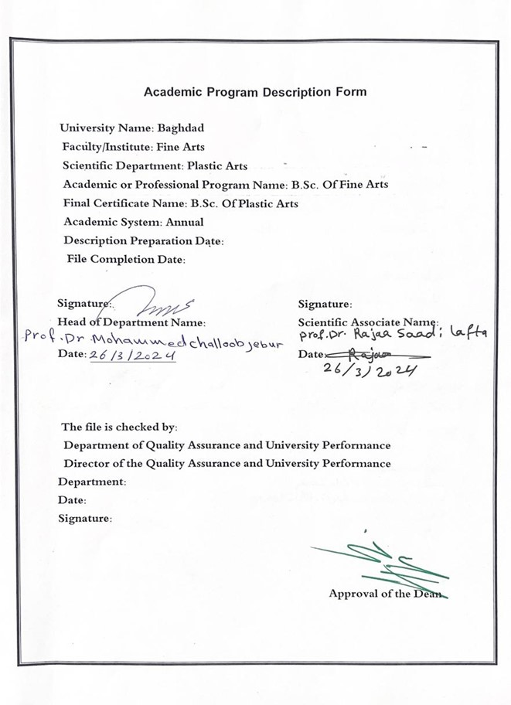

Approval of the Dean

- Program Vision
The Faculty of Fine Arts seeks to be one of the leading and distinguished higher education institutions at Baghdad University to achieve the field of modern education and scientific research through its scientific, artistic, research and administrative activities. It also works to provide an integrated path for its students and teachers to make them active and creative in serving the community in the fields of fine arts and their education.

- Program Mission
Work to prepare and graduate artistic and creative competencies in all fields of art that our college specializes in and provide knowledge and technical capital in the field of scientific research to serve the community and relevant technical institutions local, regional and international, as well as to train and refine the minds of students scientifically, cognitively and technically, emphasize social and cultural values and respond to the requirements of the local market.

- Program Objectives
- Reflecting the vision, mission and objectives of the University of Baghdad, and applying best educational practices with a focus on ensuring and promoting quality and performance.
2. Preparing specialized cadres capable of serving the community and preparing for the preparation of future disciplines.
3. Dissemination of the culture of human diversity in society, transfer of science and technical skills, writing of academic research and creative scientific and technical achievement through artistic activities focused on the student and teaching.
4. The College seeks to conclude scientific and cultural cooperation agreements with corresponding colleges and corresponding departments in different colleges to achieve best practices in the fields of education and learning of fine arts.
5. Focus on the educational and moral aspect of all its associates and create a spirit of dedication, tolerance, commitment and action to serve the nation and respect the other.
Attention to intellectual, cultural and artistic construction by opening up to other countries' experiences in all fields of art.
7. Focus on the educational and moral aspect of the student and create a spirit of dedication, tolerance, commitment and respect for the other.

- Program Accreditation
none

- Other external influences
none

- Program Structure
Program Structure | Number of Courses | Credit hours | Percentage | Reviews*
Institution Requirements | 60 | 60 |  | Basic curriculum
College Requirements | yes
Department Requirements | yes
Summer Training | none
Other
* This can include notes whether the course is basic or optional.

- Program Description
Year/Level | Course Code | Course Name | Credit Hours
23-24 tertiary |  | Art of directing | theoretical | Practical Study
 |  |  | 2 | 0

- Expected learning outcomes of the program
Knowledge
- Identify the basic principles of theater history and literature
- Gradual history of theater from the Renaissance to the modern era, passing through Asian theatre
- Going through most of the international playwrights and what are the theatrical trends they went through

Skills
The student acquires knowledge and awareness of everything that happened in the history of world theater and its literature from the Renaissance era to the present era, passing through Asian theatre.
Values
Developing students’ abilities to know the style of each playwright, what are the theatrical trends and doctrines that have occurred, and what are the reasons for these changes.

- Teaching and Learning Strategies
1- Use the practice method of theatrical directing
2- Use of brainstorming method
3- Use of Modern Means: Data Show - Film Material - Theatrical Performances - Port Point - Smart Board
4-Use of imagination in imaginary incarnation

- Evaluation methods
Weekly, monthly, daily and end-of-year exams.
The student presents mini-researches on each playwright, his direction, and his theatrical doctrine.

- Faculty
Faculty Members
Academic Rank | Specialization |  | Special Requirements/Skills (if applicable) |  | Number of the teaching staff
Academic Rank | general | Careful Study |  |  | Permanent Function | lecturer
Asst.professor | theatrical arts | Literature and theatrical criticism |  |  | Permanent Function

Professional Development
Mentoring new faculty members
According to the system of practical and theoretical participation
Professional development of faculty members
By examining the latest developments at the level of the art of directing, and at the level of the labour market, and reflecting this on the inclusion of the course in modern vocabulary compatible with the labour market.

- Acceptance Criterion
Central acceptance and special acceptance rate through talent tests

- The most important sources of information about the program
1-A History of Theater in Three Thousand Years, written by Sheldon Cheney, translated by Drini Khashaba

2 The international play written by Allardyce Nicol, translated by Mahmoud Hatmad Shawkat
3The Theory of Epic Theater by Bertolt Brecht.

- Program Development Plan
1- Studying the history of theater and its literature throughout the ages, how theatrical literary thought transformed, and what are the reasons that led to this.
2- Through dialogue and discussion, we arrive at the major transformation mechanisms in the history of theater and its literature, and what are the most important reasons that led to this transformation from the Renaissance to the modern era.

Program Skills Outline
 |  |  |  | Required program Learning outcomes
Year/Level | Course Code | Course Name | Basic or optional | Knowledge |  |  |  | Skills |  |  |  | Ethics
 |  |  |  | A1 | A2 | A3 | A4 | B1 | B2 | B3 | B4 | C1 | C2 | C3 | C4
2023-2024 |  | Art of directing | Basic curriculum | A1 | A2 | A3 |  | B1 | B2 |  |  | C1 | C2 | C3 | C4

- Please tick the boxes corresponding to the individual program learning outcomes under evaluation.

Course Description Form
- Course Name:
Theater history
- Course Code:
- Semester / Year:
the year
- Description Preparation Date:
2/3/2024
- Available Attendance Forms:
My presence only
- Number of Credit Hours (Total) / Number of Units (Total)
80 hours annually. 2 hours per week

- Course administrator's name (mention all, if more than one name)
Asst.Prof.Dr.mohammed Mahdi hassoon . email: mohammed.mohda@cofarts.uobaghdad.edu.iq
- Course Objectives
Course Objectives |  | 1 - Acquires the ability to innovate  2-It acquires the ability to imagine  3. Gains aesthetic decency through the display's structural discourse  4 - Acquires aesthetic and artistic values through his recognized experiences  5-Historical and Contemporary Art Directorial course ideas for theatrical writing.
- Teaching and Learning Strategies
Strategy | 1- The student learns the basics of theater history and literature  2- Training students on how to read the play and what transformations have occurred in theatrical literature with the presence of more than one direction and theatrical doctrine.  3- Students learn how to analyze theatrical text.

10. Rapporteur's vocabulary
Week | Hours |  | Required Learning Outcomes | Unit or subject name | Learning method | Evaluation method
Week | theoretical | practical
1 | 2 | 2 | Know the subject of this week's lesson | The Renaissance: A historical overview of medieval English theatre. | Interactive lecture and stage training | Short practical and  theoretical discussions and testing
2 | 2 | 2 | Know the subject of this week's lesson | The most important changes that occurred in the Renaissance. | How to view the material on the datacho | Short practical and  theoretical discussions and testing
3 | 2 | 2 | Know the subject of this week's lesson | The Elizabethan era and English theater in this era. | ViewFilm Material | Short practical and theoretical discussions and testing
4 | 2 | 2 | Know the subject of this week's lesson | The most important book on English theater and what happened after Queen Elizabeth. | Stage  Training | Improvising  Outreach Visions
5 | 2 | 2 | Know the subject of this week's lesson | William Shakespeare, his texts and theatrical additions. | Interactive lecture and stage training | Short practical and theoretical discussions and testing
6 | 2 | 2 | Know the subject of this week's lesson | Analysis of William Shakespeare's theatrical texts. | Stage  Training | Improvising  Outreach Visions
7 | 2 | 2 | Know the subject of this week's lesson | Henrik Ibsen and the Norwegian theater and the most important additions made by the Norwegian writer. | How to view the material on the datacho | Short practical and theoretical discussions and testing
8 | 2 | 2 | Know the subject of this week's lesson | Ibsen and the woman, Ibsen and the symbol, Ibsen and realism. | How to view  the material on the datacho and  traina practical | Short practical and theoretical discussions and testing
9 | 2 | 2 | Know the subject of this week's lesson | An analysis of some of Ibsen's Norwegian plays. | Stage  Training | Short practical and theoretical discussions and testing
10 | 2 | 2 | Know the subject of this week's lesson | Antoine Chekhov and Russian theatre. | How to view the material on the datacho | Design Script about being a play
11 | 2 | 2 | Know the subject of this week's lesson | Chekhov's theatrical additions. | How to view  the material on the datacho and  traina practical | Short practical and  theoretical discussions and testing
12 | 2 | 2 | Know the subject of this week's lesson | The features of Chekhov's theater, its comparison with Ibsen's Norwegian theater, and an analysis of Chekhov's most important texts. | How to view  the material on the datacho and  How to view  the material on the datacho and  traina practical | Comparison of different rhythms
13 | 2 | 2 | Know the subject of this week's lesson | Spanish theater and the important achievements of this theater. | How to view  the material on the datacho and  traina practical | Short practical and  theoretical discussions and testing
14 | 2 | 2 | Know the subject of this week's lesson | Garcia Lorca and the important achievements of Spanish theatre. | How to view  the material on the datacho and  traina practical | Short practical and theoretical discussions and testing
15 | 2 | 2 | Theoretical and practical exam | exam | exam
16 | 2 | 2 | Know the subject of this week's lesson | Italian theater and its most important features. | How to view  the material on the datacho and  traina practical | Short practical and  theoretical discussions and testing
17 | 2 | 2 | Know the subject of this week's lesson | The Italian writer Luigi Pirandello and an analysis of his most important texts. | How to view  the material on the datacho and  traina practical | Short practical and theoretical discussions and testing
18 | 2 | 2 | Know the subject of this week's lesson | The most important themes of Pirandello’s works and his importance in media theatre. | How to view  the material on the datacho and  traina practical | Short practical and  theoretical discussions and testing
19 | 2 | 2 | Know the subject of this week's lesson | Bertolt Brecht and the German theatre. | How to view the material on the datacho | Short practical and theoretical discussions and testing
20 | 2 | 2 | Know the subject of this week's lesson | The theory of epic theater by Bertolt Brecht. | How to view  the material on the datacho and  traina practical | Improvising various theatre movements
21 | 2 | 2 | Know the subject of this week's lesson | The most important works of Bertolt Brecht. | How to view  the material on the datacho and  traina practical | A dynamic foundation for a global play
22 | 2 | 2 | Know the subject of this week's lesson | Arthur Miller and the American theatre. | How to view  the material on the datacho and  traina practical | Short practical and theoretical discussions and testing
23 | 2 | 2 | Know the subject of this week's lesson | Characteristics of Arthur Miller's theater and an analysis of his most important plays. | How to view  the material on the datacho and  traina practical | Short practical and  theoretical discussions and testing
24 | 2 | 2 | Know the subject of this week's lesson | Theater of the absurd or theater of the absurd. | How to view  the material on the datacho and  traina practical | Improvisation of graduate recruitment applications
25 | 2 | 2 | Know the subject of this week's lesson | The most important plays of the Theater of the Absurd or the Absurd. | How to view  the material on the datacho and  traina practical | Short practical and theoretical discussions and testing
26 | 2 | 2 | Know the subject of this week's lesson | Characteristics of the theater of the absurd or the absurd. | How to view  the material on the datacho and  traina practical | Short practical and theoretical discussions and testing
27 | 2 | 2 | Know the subject of this week's lesson | Asian theatre. | How to view  the material on the datacho and  traina practical | Improvising a realistic scene
28 | 2 | 2 | Know the subject of this week's lesson | Indian kathikali theater and its most important characteristics. | How to view  the material on the datacho and  traina practical | Short practical and theoretical discussions and testing
29 | 2 | 2 | Know the subject of this week's lesson | Japanese theater and Chinese theater. | How to view  the material on the datacho and  traina practical | Short practical and theoretical  discussions and  testing
30 | 2 | 2 | exam | exam | exam

11.Course Evaluation
Distribution as follows: 30 degrees monthly and daily examinations for the first semester divided (10 theoretical - 20 practical). 30 degrees monthly and daily examinations for the second semester divided (10 theoretical - 20 practical). 40 degrees for final examinations divided (15 theoretical - 25 practical).
12Learning and Teaching Resources
Required textbooks (curricular books, if any) | none
Main references (sources) | 1-Principles of Theatre Directing/Written by Badri Hasson Farid  and Sami Abdul Hamid  2-Foundations of Theatre Directing/by Alexander Dean  3-Art of Directing = by Zigmont Hepner  4-Theatre Directing/Writing by Henning Nielms  5-Film material on global directors' experiences
Recommended books and references (scientific journals, reports...) | stage Magazine, Academic Magazine
Electronic References, Websites | Sober electronic links in the practical and theoretical aspects

