

Ministry of Higher Education and Scientific Research
Scientific Supervision and Scientific Evaluation Apparatus
Directorate of Quality Assurance and Academic Accreditation
Accreditation Department




Academic Program and Course Description Guide Academic Program and Course Description Guide
Academic Program and Course Description Guide

2024
Introduction:
The educational program is a well-planned set of courses that include procedures and experiences arranged in the form of an academic syllabus. Its main goal is to improve and build graduates' skills so they are ready for the job market. The program is reviewed and evaluated every year through internal or external audit procedures and programs like the External Examiner Program.
The academic program description is a short summary of the main features of the program and its courses. It shows what skills students are working to develop based on the program's goals. This description is very important because it is the main part of getting the program accredited, and it is written by the teaching staff together under the supervision of scientific committees in the scientific departments.
This guide, in its second version, includes a description of the academic program after updating the subjects and paragraphs of the previous guide in light of the updates and developments of the educational system in Iraq, which included the description of the academic program in its traditional form (annual, quarterly), as well as the adoption of the academic program description circulated according to the letter of the Department of Studies T 3/2906 on 3/5/2023 regarding the programs that adopt the Bologna Process as the basis for their work.
In this regard, we can only emphasize the importance of writing an academic programs and course description to ensure the proper functioning of the educational process

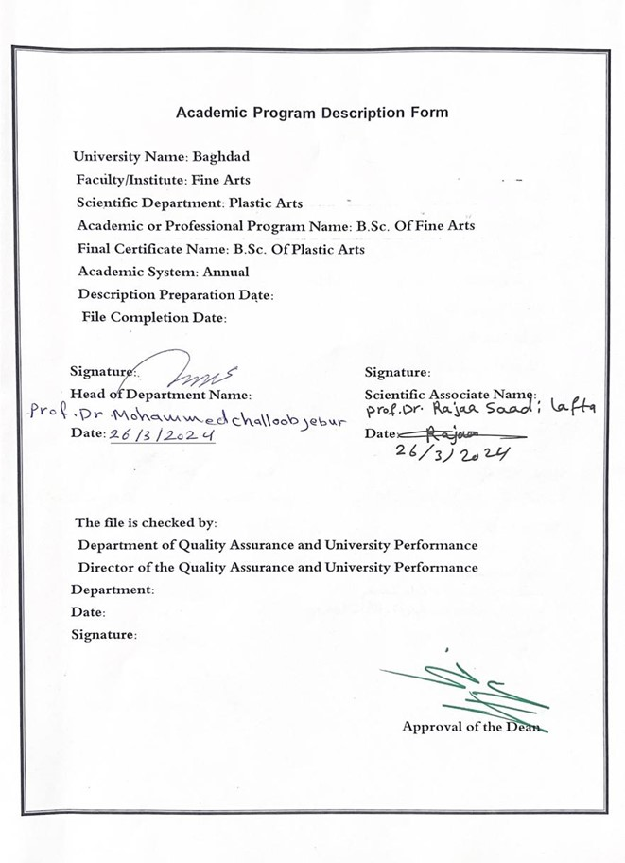

Approval of the Dean

- Program Vision
The Faculty of Fine Arts seeks to be one of the leading and distinguished higher education institutions at Baghdad University to achieve the field of modern education and scientific research through its scientific, artistic, research and administrative activities. It also works to provide an integrated path for its students and teachers to make them active and creative in serving the community in the fields of fine arts and their education.

- Program Mission
Work to prepare and graduate artistic and creative competencies in all fields of art that our college specializes in and provide knowledge and technical capital in the field of scientific research to serve the community and relevant technical institutions local, regional and international, as well as to train and refine the minds of students scientifically, cognitively and technically, emphasize social and cultural values and respond to the requirements of the local market.

- Program Objectives
- Reflecting the vision, mission and objectives of the University of Baghdad, and applying best educational practices with a focus on ensuring and promoting quality and performance.
2. Preparing specialized cadres capable of serving the community and preparing for the preparation of future disciplines.
3. Dissemination of the culture of human diversity in society, transfer of science and technical skills, writing of academic research and creative scientific and technical achievement through artistic activities focused on the student and teaching.
4. The College seeks to conclude scientific and cultural cooperation agreements with corresponding colleges and corresponding departments in different colleges to achieve best practices in the fields of education and learning of fine arts.
5. Focus on the educational and moral aspect of all its associates and create a spirit of dedication, tolerance, commitment and action to serve the nation and respect the other.
Attention to intellectual, cultural and artistic construction by opening up to other countries' experiences in all fields of art.
7. Focus on the educational and moral aspect of the student and create a spirit of dedication, tolerance, commitment and respect for the other.

- Program Accreditation
none

- Other external influences
none

- Program Structure
Program Structure | Number of Courses | Credit hours | Percentage | Reviews*
Institution Requirements | 80 | 80 |  | Basic curriculum
College Requirements | yes
Department Requirements | yes
Summer Training | none
Other
* This can include notes whether the course is basic or optional.

- Program Description
Year/Level | Course Code | Course Name | Credit Hours
23-24 the second |  | Theatrical fitness | theoretical | Practical Study
 |  |  |  | 2

- Expected learning outcomes of the program
Knowledge
1- Identify the basic principles of theatrical movement.
2- Work on applying theories of the art of acting and their importance in the work of the actor’s body.
3- Training students on the mechanisms of presenting characters on stage.
Skills
1 - Students’ ability to know and distinguish types of movement and their importance on stage.
2 - Applying students to choosing and implementing theatrical movements.
Values
Developing students’ abilities to participate in performing scenes on stage in different ways

- Teaching and Learning Strategies
1- Using various means of explanation in learning.
2- Using the smart board for clarification purposes.

- Evaluation methods
1. Weekly and quarterly exams and the end-of-year exam.
2. Discussion and commitment to attend the lesson.

- Faculty
Faculty Members
Academic Rank | Specialization |  | Special Requirements/Skills (if applicable) |  | Number of the teaching staff
Academic Rank | general | Careful Study |  |  | Permanent Function | lecturer
professor | theatrical arts | acting |  |  | Permanent Function

Professional Development
Continuous knowledge and practical participation
Professional development of faculty members
By examining the latest developments at the level of the art of directing, and at the level of the labour market, and reflecting this on the inclusion of the course in modern vocabulary compatible with the labour market.

- Acceptance Criterion
Central acceptance and special acceptance rate through talent tests

- The most important sources of information about the program
Prescribed methodological books, works and translations, works by Sami Abdel Hamid

- Program Development Plan
Study of theatrical movement within its typical forms and types.
Work on designing and implementing a theatrical movement in accordance with scientific and academic standards

Program Skills Outline
 |  |  |  | Required program Learning outcomes
Year/Level | Course Code | Course Name | Basic or optional | Knowledge |  |  |  | Skills |  |  |  | Ethics
 |  |  |  | A1 | A2 | A3 | A4 | B1 | B2 | B3 | B4 | C1 | C2 | C3 | C4
2023-2024 |  | Theatrical collar | Basic curriculum | A1 | A2 | A3 |  | B1 | B2 |  |  | C1 | C2 | C3 | C4

- Please tick the boxes corresponding to the individual program learning outcomes under evaluation.

Course Description Form
- Course Name:
Theatrical fitness
- Course Code:
- Semester / Year:
the year
- Description Preparation Date:
2/3/2024
- Available Attendance Forms:
My presence only
- Number of Credit Hours (Total) / Number of Units (Total)
60 hours

- Course administrator's name (mention all, if more than one name)
Dr.. Haider Atallah Abdul Ali. email: atallah@cofarts.uobaghdad.edu.iq
- Course Objectives
Course Objectives |  | - Teaching the student the principles of the art of theatrical movement.  - Training students on how to present theatrical characters.  - Teaching students the history of theatrical movement throughout the ages.  - Teaching students the importance of theatrical movement consistent with the directing style.
- Teaching and Learning Strategies
Strategy | 1-Use the practice method of theatrical directing  2-Use of brainstorming method  3- Representative education strategy

10. Rapporteur's vocabulary
Week | Hours |  | Required Learning Outcomes | Unit or subject name | Learning method | Evaluation method
Week | theoretical | practical
1 |  | 2 | Know the subject of this week's lesson | 1_ Warm-up exercises | Interactive lecture and stage training | Short practical and  theoretical discussions and testing
2 |  | 2 | Know the subject of this week's lesson | 2_ Warm-up exercises | How to view the material on the datacho | Short practical and  theoretical discussions and testing
3 |  | 2 | Know the subject of this week's lesson | 3_ Warm-up exercises | ViewFilm Material | Short practical and theoretical discussions and testing
4 |  | 2 | Know the subject of this week's lesson | 4_ Relaxation and breathing exercises | Stage  Training | Improvising  Outreach Visions
5 |  | 2 | Know the subject of this week's lesson | 5_ Relaxation and breathing exercises | Interactive lecture and stage training | Short practical and theoretical discussions and testing
6 |  | 2 | Know the subject of this week's lesson | 6_ Relaxation and breathing exercises | Stage  Training | Improvising  Outreach Visions
7 |  | 2 | Know the subject of this week's lesson | 7_ Relaxation and breathing exercises | How to view the material on the datacho | Short practical and theoretical discussions and testing
8 |  | 2 | Know the subject of this week's lesson | 8_ Motor formation exercises | How to view  the material on the datacho and  traina practical | Short practical and theoretical discussions and testing
9 |  | 2 | Know the subject of this week's lesson | 9_ Motor formation exercises | Stage  Training | Short practical and theoretical discussions and testing
10 |  | 2 | Know the subject of this week's lesson | 10_ Motor formation exercises | How to view the material on the datacho | Design Script about being a play
11 |  | 2 | Know the subject of this week's lesson | 11_ Motor formation exercises | How to view  the material on the datacho and  traina practical | Short practical and  theoretical discussions and testing
12 |  | 2 | Know the subject of this week's lesson | 12_ Rhythmic movements exercises | Stage  Training | Comparison of different rhythms
13 |  | 2 | Know the subject of this week's lesson | 13_ Rhythmic movements exercises | How to view  the material on the datacho and  traina practical | Short practical and  theoretical discussions and testing
14 |  | 2 | Know the subject of this week's lesson | 14_ Rhythmic movements exercises | Stage  Training | Short practical and theoretical discussions and testing
15 |  | 4 | Theoretical and practical exam | 15_ First semester exam  Vacation | exam | Presenting an  integrated theatrical scene - theoretical options exam
16 |  | 2 | Know the subject of this week's lesson | 16_ Types of movement exercises | How to view the material on the 2datacho | Short practical and  theoretical discussions and testing
17 |  | 2 | Know the subject of this week's lesson | 17_ Types of movement exercises | How to view the material on the datacho | Short practical and theoretical discussions and testing
18 |  | 2 | Know the subject of this week's lesson | 18 _ Types of movement exercises | Stage  Training | Short practical and  theoretical discussions and testing
19 |  | 2 | Know the subject of this week's lesson | 19_ Concentration exercises | How to view the material on the datacho | Short practical and theoretical discussions and testing
20 |  | 2 | Know the subject of this week's lesson | 20_ Concentration exercises | Stage  Training | Improvising various theatre movements
21 |  | 2 | Know the subject of this week's lesson | 21_ Concentration exercises | Stage  Training | A dynamic foundation for a global play
22 |  | 2 | Know the subject of this week's lesson | 22_ Concentration exercises | How to view  the material on the datacho and  traina practical | Short practical and theoretical discussions and testing
23 |  | 2 | Know the subject of this week's lesson | 23_ Imagination exercises | Stage  Training | Short practical and  theoretical discussions and testing
24 |  | 2 | Know the subject of this week's lesson | 24_ Imagination exercises | Stage  Training | Improvisation of graduate recruitment applications
25 |  | 2 | Know the subject of this week's lesson | 25_ Imagination exercises | How to view  the material on the datacho and  traina practical | Short practical and theoretical discussions and testing
26 |  | 2 | Know the subject of this week's lesson | 26_ Imagination exercises | Lecture  (Data Show) | Short practical and theoretical discussions and testing
27 |  | 2 | Know the subject of this week's lesson | 27_ Fencing exercises. | Stage  Training | Improvising a realistic scene
28 |  | 2 | Know the subject of this week's lesson | 28_ Fencing exercises. | How to view  the material on the datacho and  traina practical | Short practical and theoretical discussions and testing
29 |  | 2 | Know the subject of this week's lesson | 29_ Fencing exercises. | Stage  Training | Short practical and theoretical  discussions and  testing
30 |  | 2 | exam | 30_ Exam | exam | Presentingan integrated theatrical scene - theoretical options exam

11.Course Evaluation
Distribution is as follows: 50 marks for monthly exams for the first practical semester. 50 marks for monthly practical exams for the second semester.
12Learning and Teaching Resources
Required textbooks (curricular books, if any) | None
Main references (sources) | Prescribed methodological books, Stanlavsky's works  Works by Dr. Sami Abdel Hamid.
Recommended books and references (scientific journals, reports...) | Translated books and Arabic sources that address the topic of theatrical movement design.
Electronic References, Websites | Sober electronic links in the practical and theoretical aspects

