

Ministry of Higher Education and Scientific Research
Scientific Supervision and Scientific Evaluation Apparatus
Directorate of Quality Assurance and Academic Accreditation
Accreditation Department

Academic Program and Course Description Guide Academic Program and Course Description Guide
Academic Program and Course Description Guide

2024
Introduction:
The educational program is a well-planned set of courses that include procedures and experiences arranged in the form of an academic syllabus. Its main goal is to improve and build graduates' skills so they are ready for the job market. The program is reviewed and evaluated every year through internal or external audit procedures and programs like the External Examiner Program.
The academic program description is a short summary of the main features of the program and its courses. It shows what skills students are working to develop based on the program's goals. This description is very important because it is the main part of getting the program accredited, and it is written by the teaching staff together under the supervision of scientific committees in the scientific departments.
This guide, in its second version, includes a description of the academic program after updating the subjects and paragraphs of the previous guide in light of the updates and developments of the educational system in Iraq, which included the description of the academic program in its traditional form (annual, quarterly), as well as the adoption of the academic program description circulated according to the letter of the Department of Studies T 3/2906 on 3/5/2023 regarding the programs that adopt the Bologna Process as the basis for their work.
In this regard, we can only emphasize the importance of writing an academic programs and course description to ensure the proper functioning of the educational process
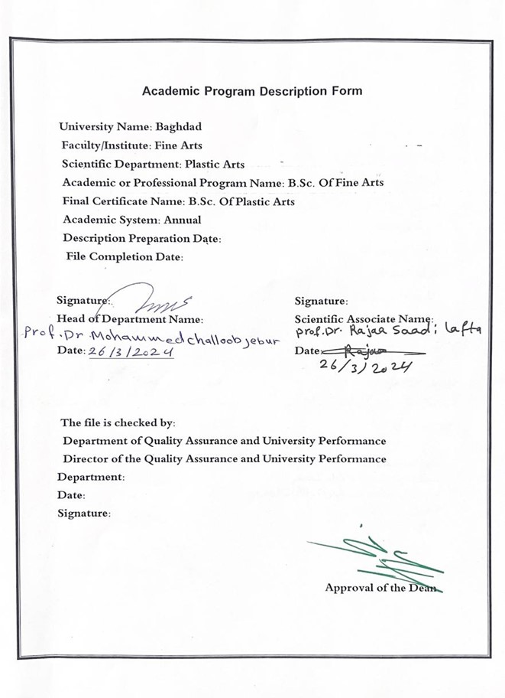

Approval of the Dean

- Program Vision
The College of Fine Arts seeks to be one of the leading higher education institutions at the University of Baghdad in the field of modern education and scientific research through its scientific, research and administrative activities. It also works to provide an integrated path for its students and professors to make them active and creative in serving the community in the fields of learning and teaching living languages

- Program Mission Working to prepare and graduate leading scientific and leadership competencies in the field of modern theatrical techniques in order to develop the balance of knowledge in the field of theoretical and applied scientific research to serve the local, regional and international community, as well as training and refining the minds of students scientifically and cognitively, and emphasizing social and cultural values ​​and responding to the requirements of the local market.

- Program Objectives
1. Embodying the vision, mission and goals of the University of Baghdad, and applying the best educational practices with a focus on ensuring and enhancing quality and performance.
2. Preparing specialized cadres capable of serving the community and preparing for the preparation of future specializations.
3. Spreading the culture of artistic and human diversity in society, transferring technical and applied knowledge and skills, writing academic research, and creative scientific achievement through student- and teaching-focused activities.
4. The college seeks to conclude scientific, cultural, and artistic cooperation agreements with corresponding colleges to achieve best practices in the fields of technical education
5. Focusing on the educational and moral aspects of all its members and spreading the spirit of dedication, tolerance, commitment and work to serve the nation.
6. Paying attention to intellectual and cultural construction through openness to the experiences of other countries in the fields of modern theatrical techniques

- Program Accreditation: Non

- Other external influences: Non

- Program Structure
Program Structure | Number of Courses | Credit hours | Percentage | Reviews*
Institution Requirements | 90 | 90 |  | Basic course
College Requirements | Yes
Department Requirements | yes
Summer Training | Non
Other
* This can include notes whether the course is basic or optional.

- Program Description
Year/Level | Course Code | Course Name | Credit Hours
2023-2024/third |  | Modern techniques | theoretical | practical
 |  |  | 1 | 2

- Expected learning outcomes of the program
Knowledge
1. Identify the basic principles of design and implementation of the digital landscape.
2. Work on applying digital technology in the scenography of theatrical performance
Skills
1. The student has the ability and competence to design and implement the scenography of a theatrical performance.
2. The student has the ability to link technology with art, which is the aesthetic quality that characterizes the artistic process by transforming the latent into the apparent.
Value
Developing students’ abilities to imagine, innovate, share ideas, and embody them on stage

Acquiring aesthetic, artistic and scientific values ​​by learning about modern technical experiments

- Teaching and Learning Strategies
- Using various means of explanation in learning.
- Using the computer and its software for learning.
- Using the data show screen as a digital alternative to scenery and theatrical lighting.
- Adopting practical procedures on stag

- Evaluation methods
Adopting theoretical and practical tests applied on stage reveals the extent to which the material is strengthened among students

- Faculty
Faculty Members
Academic Rank | Specialization |  | Special Requirements/Skills (if applicable) |  | Number of the teaching staff
Academic Rank | general | Specific |  |  | staff | lesturers
Professor | Theatrical arts | Lighting theater |  |  | staff

Professional Development
Mentoring new faculty members
According to the system of participation in the theoretical and practical aspects and developing themselves through participation in workshops on modern theatrical techniques
Professional development of faculty members
Accessing and benefiting from modern theater experiences based on digital technologies, as well as the requirements of the production market for that, and thus all of this is reflected in the study curricula.

- Acceptance Criterion
Central admission and talent, and before that, tests, as well as conducting special tests to reveal technical talent, which includes knowledge of the computer and its software, as well as the student’s mental ability to deal with technology, which through its technical means has formed various human activities, the most prominent feature of the era, with its continuous presence in the areas of life, the doors of science, and human needs

- The most important sources of information about the program
1. The relationship between digital media and the concept of simulation in the theatrical performance space, written by Mahmoud Sabry, one of the publications of the Cairo International Festival for Experimental Theater, 29th session of 2022.
2. Theater, Experimentation, and Technology, translated and presented by Muhammad Seif, and one of the publications of the Cairo International Festival for Experimental Theater, 29th session, 2022.
3. Alternative theatrical lighting by Dr. Imad Hadi Abbas, published by the Arab Theater Authority 2020.
4. Art design philosophy. Theory.Application. Part 1, Part 2, Part 3, by Dr. Iyad Al-Hussein, published by the House of Culture and Information, Sharjah Government, 2008.
5. The Digital Age and the Information Revolution by Dr. Mohamed Salah Salem, Ain Foundation for Human and Social Studies and Research,
6. Creativity in Art and Science by Dr. Hassan Ahmed Issa, published by the World of Knowledge, 1978..
And other translated books concerned with the subject

- Program Development Plan
By working to update the vocabulary each year by 10 percent and following up on the labor market in updating the vocabulary, as well as holding educational workshops for students and those interested in digital technologies and theater on a regular basis.

Program Skills Outline
 |  |  |  | Required program Learning outcomes
Year/Level | Course Code | Course Name | Basic or optional | Knowledge |  |  |  | Skills |  |  |  | Ethics
 |  |  |  | A1 | A2 | A3 | A4 | B1 | B2 | B3 | B4 | C1 | C2 | C3 | C4
2023-2024 |  |  |  | A1 | A2 | A3 |  | B1 | B2 |  |  | C1 | C2 | C3 | C4

- Please tick the boxes corresponding to the individual program learning outcomes under evaluation.

Course Description Form
- Course Name: Modern techniques
This course description provides a concise summary of the most important course
characteristics and the learning outcomes expected of the student and their achievement
so that the student demonstrates Whether he has made the most of the available learning opportunities,
and this must be linked to the program description
- Course Code:
- Semester / Year:
Annual
- Description Preparation Date:
29/2/ 2024
- Available Attendance Forms:
My presence only
- Number of Credit Hours (Total) / Number of Units (Total)
90 hours annually. 3 hours per week

- Course administrator's name (mention all, if more than one name)
Prof.D.aseel laeth ahmad, Email: asil.l@cofarts.uobaghdad.edu.iq

- Course Objectives
Course Objectives |  |  |  | 1.Learn about the basic principles of design and implementation of the digital landscape.  2. Work on applying digital technology in the scenography of theatrical performances
- Teaching and Learning Strategies
Strategy |  | 1. Brainstorming strategy and opening the door to discussion for the course.  2. Education strategy by listening to lectures and discussion sessions and actively participating in discussions and practical applications of theoretical material.  3. A strategy for identifying viewers for theatrical, Arab, and European shows that includes diversity using digital technology in all elements of the theatrical show.
- Course Structure
Week | Hours |  | Required Learning Outcomes |  |  |  | Unit or subject name | Learning method | Evaluation method
1st | 3 hours |  | The student’s ability to know the topic studied this week |  |  |  | Definition stage | giving a lecture  Theoretical exam
2nd | 3 hours |  | The student’s ability to know the topic studied this week |  |  |  | Definition stage | giving a lecture  Theoretical exam
3rd | 3 hours |  | The student’s ability to know the topic studied this week |  |  |  | Properties of light | giving a lecture  Theoretical exam
4th | 3 hours |  | The student’s ability to know the  topic studied this week |  |  |  | Properties of light | giving a lecture  Theoretical exam
5th | 3 hours |  | The student’s ability to know the  topic studied this week |  |  |  | Function of stage lighting | practical practicing  Theoretical exam
6th | 3 hours |  | The student’s ability to know the topic studied this week |  |  |  | Function of stage lighting | giving a lecture  Theoretical exam
7th | 3 hours |  | The student’s ability to know the topic studied this week |  |  |  | Examination | giving a lecture Theoretical exam
8th | 3 hours |  | The student’s ability to know the topic studied this week |  |  |  | History of stage lighting | giving a lecture  practical exam
9th | 3 hours |  | The student’s ability to know the topic studied this week |  |  |  | History of stage lighting | giving a lecture  Theoretical exam
10th | 3 hours |  | The student’s ability to know the topic studied this week |  |  |  | Fundamentals light .laws of light | giving a lecture  practical exam
11th | 3 hours |  | The student’s ability to know the topic studied this week |  |  |  | Fundamentals light. laws of light | giving a lecture  Theoretical exam
12th | 3 hours |  | The student’s ability to know the topic studied this week |  |  |  | Lighting instruments | giving a lecture  Theoretical exam
13th | 3 hours |  | The student’s ability to know the  topic studied this week |  |  |  | Lighting instruments | practical practicing  Theoretical exam
14th | 3 hours |  | The student’s ability to know the topic studied this week |  |  |  | Examination | Make an examination  Theoretical exam
15th | 3 hours |  | The student’s ability to know the  topic studied this week |  |  |  | Standard of indigent | giving a lecture  Theoretical exam
16th | 3 hours |  | The student’s ability to know the  topic studied this week |  |  |  | Standard of indigent | giving a lecture  Theoretical exam
17th | 3 hours |  | The student’s ability to know the  topic studied this week |  |  |  | Color,additive,and subtractive mixtures. Pigments mixture | giving a lecture  Theoretical exam
18th | 3 hours |  | The student’s ability to know the  topic studied this week |  |  |  | Color,additive,and subtractive mixtures. Pigments mixture | giving a lecture  Theoretical exam
19th | 3 hours |  | The student’s ability to know the  topic studied this week |  |  |  | Color media | giving a lecture  Theoretical exam
20th | 3 hours |  | The student’s ability to know the  topic studied this week |  |  |  | Color media | giving a lecture Theoretical exam
21st | 3 hours |  | The student’s ability to know the  topic studied this week |  |  |  | Examination | giving a lecture  Theoretical exam
22nd | 3 hours |  | The student’s ability to know the  topic studied this week |  |  |  | Light and make-up, light and costumes, light and scenery | giving a lecture  Theoretical exam
23rd | 3 hours |  | The student’s ability to know the  topic studied this week |  |  |  | Color symbolism | giving a lecture  Theoretical exam
24th | 3 hours |  | The student’s ability to know the  topic studied this week |  |  |  | Color symbolism | giving a lecture  Theoretical exam
25th | 3 hours |  | The student’s ability to know the  topic studied this week |  |  |  | Lighting practice, acting area and background | giving a lecture  practical exam
26th | 3 hours |  | The student’s ability to know the  topic studied this week |  |  |  | Lighting practice, acting area and background | giving a lecture  practical exam
27th | 3 hours |  | The student’s ability to know the  topic studied this week |  |  |  | Lighting plat and light procedure | giving a lecture Theoretical exam
28th | 3 hours |  | The student’s ability to know the  topic studied this week |  |  |  | Lighting plat and light procedure | giving a lecture  Theoretical exam
29th | 3 hours |  | The student’s ability to know the  topic studied this week |  |  |  | Examination | giving a lecture  practical exam
30th | 3 hours |  | The student’s ability to know the  topic studied this week |  |  |  | Examination | giving a lecture  practical exam
- Course Evaluation
The distribution is as follows: 30 marks for the monthly exams for the first semester, divided into
10 theoretical and 20 practical, as well as for the second semester. As for the final exam,
the grade is distributed from 40, 15 theoretical and 25 practical

- Learning and Teaching Resources
Required textbooks (curricular books, if any) |  |  |  |  | 1. The relationship between digital media and the  concept of simulation in the theatrical performance space, written by Mahmoud Sabry, one of the publications of the Cairo International Festival for Experimental Theater, 29th session of 2022.  2. Theater, Experimentation, and Technology, translated and presented by Muhammad Seif, and one of the publications of the Cairo International Festival for Experimental Theater, 29th session, 2022.  3. Alternative theatrical lighting by Dr. Imad Hadi Abbas, published by the Arab Theater Authority 2020.  4. Art design philosophy. Theory.Application. Part 1, Part 2, Part 3, by Dr. Iyad Al-Hussein, published by the House of Culture and Information, Sharjah Government, 2008.  5. The Digital Age and the Information Revolution by Dr. Mohamed Salah Salem, Ain Foundation for Human and Social Studies and Research.  6. Creativity in Art and Science by Dr. Hassan Ahmed Issa, published by the World of Knowledge 1978 and other translated books concerned with the subject.
Main references (sources)
Recommended books and references (scientific journals, reports...) |  |  |  |  |  | - Academic magazine  - Al Khashaba Magazine
Electronic References, Websites |  |  |  |  |  | All electronic references and websites concerned with  modern theatrical techniques

