

Ministry of Higher Education and Scientific Research
Scientific Supervision and Scientific Evaluation Apparatus
Directorate of Quality Assurance and Academic Accreditation
Accreditation Department

Academic Program and Course Description Guide Academic Program and Course Description Guide
Academic Program and Course Description Guide

2024
Introduction:
The educational program is a well-planned set of courses that include procedures and experiences arranged in the form of an academic syllabus. Its main goal is to improve and build graduates' skills so they are ready for the job market. The program is reviewed and evaluated every year through internal or external audit procedures and programs like the External Examiner Program.
The academic program description is a short summary of the main features of the program and its courses. It shows what skills students are working to develop based on the program's goals. This description is very important because it is the main part of getting the program accredited, and it is written by the teaching staff together under the supervision of scientific committees in the scientific departments.
This guide, in its second version, includes a description of the academic program after updating the subjects and paragraphs of the previous guide in light of the updates and developments of the educational system in Iraq, which included the description of the academic program in its traditional form (annual, quarterly), as well as the adoption of the academic program description circulated according to the letter of the Department of Studies T 3/2906 on 3/5/2023 regarding the programs that adopt the Bologna Process as the basis for their work.
In this regard, we can only emphasize the importance of writing an academic programs and course description to ensure the proper functioning of the educational process

Concepts and terminology:

Academic Program Description: The academic program description provides a brief summary of its vision, mission and objectives, including an accurate description of the targeted learning outcomes according to specific learning strategies.
Course Description: Provides a brief summary of the most important characteristics of the course and the learning outcomes expected of the students to achieve, proving whether they have made the most of the available learning opportunities. It is derived from the program description.
Program Vision: An ambitious picture for the future of the academic program to be sophisticated, inspiring, stimulating, realistic and applicable.
Program Mission: Briefly outlines the objectives and activities necessary to achieve them and defines the program's development paths and directions.
Program Objectives: They are statements that describe what the academic program intends to achieve within a specific period of time and are measurable and observable.
Curriculum Structure: All courses / subjects included in the academic program according to the approved learning system (quarterly, annual, Bologna Process) whether it is a requirement (ministry, university, college and scientific department) with the number of credit hours.
Learning Outcomes: A compatible set of knowledge, skills and values acquired by students after the successful completion of the academic program and must determine the learning outcomes of each course in a way that achieves the objectives of the program.
Teaching and learning strategies: They are the strategies used by the faculty members to develop students’ teaching and learning, and they are plans that are followed to reach the learning goals. They describe all classroom and extra-curricular activities to achieve the learning outcomes of the program.
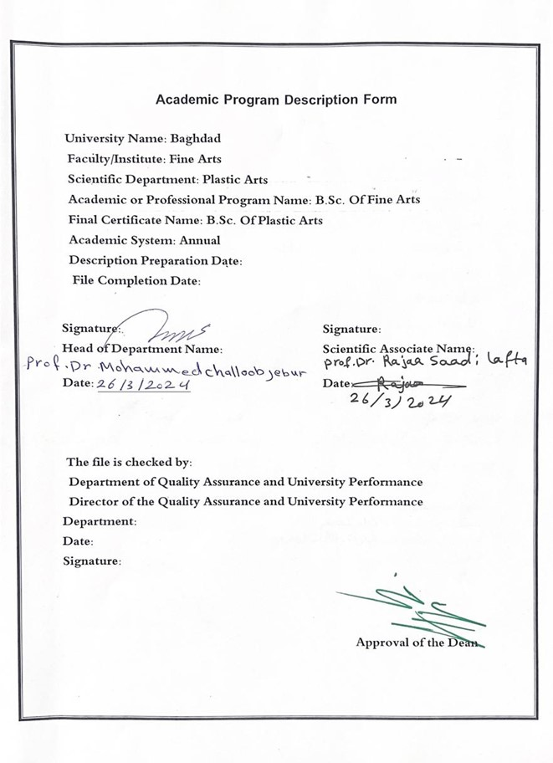

- Program Vision
The College of Fine Arts seeks to be one of the leading higher education institutions at the University of Baghdad in the field of modern education and scientific research through its artistic, scientific, practical and administrative activities. It also works to provide an integrated path for its students and professors to make them active and creative in serving the community in the fields of fine arts and teaching.

- Program Mission
Working to prepare and graduate artistic competencies and creators in all fields of arts that the college specializes in, as well as in the field of scientific research to serve the community and artistic institutions, as well as training and refining the minds of students scientifically and cognitively, and emphasizing social and cultural values ​​and responding to the requirements of the local market.

- Program Objectives
1-Embodying the vision, mission and goals of the University of Baghdad, and applying the best educational practices with a focus on ensuring and enhancing quality and performance.
2-Preparing specialized cadres capable of serving the community and preparing for the preparation of future specializations.
3-Spreading the culture of human diversity in society, transferring knowledge, writing academic research, and creative scientific achievement through student- and teaching-focused activities.
4-The college seeks to conclude scientific and cultural cooperation agreements with corresponding colleges and corresponding departments in different colleges to achieve best practices in the fields of education and learning.
5-Focusing on the educational and moral aspects of all its members and spreading the spirit of dedication, tolerance, commitment and work to serve the nation.
6-Paying attention to intellectual and cultural construction through openness to the experiences of other countries in the fields of arts.
7- Focusing on the educational and moral aspect of the student and instilling a spirit of dedication, tolerance, commitment and respect for others.

- Program Accreditation
Nothing

- Other external influences
Nothing

- Program Structure
Program Structure | Number of Courses | Credit hours | Percentage | Reviews*
Institution Requirements | 60 | 60 |  | Basic course
College Requirements | Yes
Department Requirements | Yes
Summer Training | Nothing
Other
* This can include notes whether the course is basic or optional.

- Program Description
Year/Level | Course Code | Course Name | Credit Hours
2023-2024/second |  | History of civilization | theoretical
 |  |  | 2

- Expected learning outcomes of the program
Knowledge
1-The student learns about the history of the Mesopotamian and Nile Valley civilizations and the cultural roles they went through.
2- The student learns about the way of life, religious beliefs, the nature of the ruling systems, and the most important laws that were followed in the two civilizations.
Skills
The student acquires scientific skills through reading, thinking, understanding, tracking details, and continuous research.

Ethics
cognitive value that students gain through continuous research
Developing students’ abilities to share ideas

- Teaching and Learning Strategies
Explanation and direct delivery - and discussion - discovery method - story method - role-playing method - brainstorming method - field trips and visits - self-learning method.

- Evaluation methods
Daily, weekly, monthly exams and the end of the year exam.

- Faculty
Faculty Members
Academic Rank | Specialization |  | Special Requirements/Skills (if applicable) |  | Number of the teaching staff
Academic Rank | General | Special |  |  | Staff | Lecturer
assistant teacher | Arabic  language | Modern literature and criticism

Professional Development
Mentoring new faculty members
According to the system of participation in the scientific and theoretical aspects.
Professional development of faculty members
By reviewing the most important modern sources that are compatible with the level of the labor market.

- Acceptance Criterion
Central admission and special admission rates through tests for the gifted.

- The most important sources of information about the program
Customs and traditions of ancient peoples / written by Fadel Abdel Wahed - Amer Suleiman
Introduction to the history of ancient civilizations / written by Taha Baqir
History of the Ancient Arab World/ Written by a specialized committee from the Center for Educational Curricula, Research and Pedagogy
History of Mesopotamia / written by Avram Issa Youssef
Egypt at the dawn of history / written by Geoffrey Spencer
History of peoples and civilizations in the Nile Valley / written by Emil Ludwig
The Nile Valley Civilization / written by Muhammad Ali

- Program Development Plan
Updating vocabulary, and learning about the most prominent studies in the field of historical studies and through discussions during lectures.

Program Skills Outline
 |  |  |  | Required program Learning outcomes
Year/Level | Course Code | Course Name | Basic or optional | Knowledge |  |  |  | Skills |  |  |  | Ethics
 |  |  |  | A1 | A2 | A3 | A4 | B1 | B2 | B3 | B4 | C1 | C2 | C3 | C4
2023-2024 |  | History of civilization |  | A1 | A2 | A3 |  | B2 | B2 |  |  | G1 | G2 | G3 | G4

- Please tick the boxes corresponding to the individual program learning outcomes under evaluation.

Course Description Form
- Course Name:
Mesopotamia and Nile Valley Civilization

- Course Code:
- Semester / Year:
Annual

- Description Preparation Date:
2/ 03/ 2024

- Available Attendance Forms:
Attendance only

- Number of Credit Hours (Total) / Number of Units (Total)
60 hours annually.
2 hours a week

- Course administrator's name (mention all, if more than one name)
Name:MA. Asmahan Abdel Quddus Abdel Rahman

Email: asmahan.a.393@cofarts.uobaghdad.edu.iq

- Course Objectives
1- Make students fully aware of the history of their nation and take pride in its cultural and human heritage.  2- Giving the student a complete idea about the civilization of Mesopotamia and the Nile Valley in ancient history during the prehistoric period through his study of a number of early historical eras,  The main objective of this course is to:  The student learns the most important historical stages that the two civilizations went through. |  |  |  |  |  |  | - .....  - .....  - .....
- Teaching and Learning Strategies
Strategy |  |  |  | 1- Using modern means and maps to convey information.  2- Use the brainstorming method.  3-Use the topic-specific series of notes method.
- Course Evaluation

Week | Hours |  | Required Learning Outcomes |  | Unit or subject name |  |  | Learning method |  | Evaluation method
Week | theoretical | practical
1 | 2 |  | Know the subject of this week's lesson |  | Civilization of ancient Iraq |  |  | Interactive lecture  and stage training | Discussion on the topic
2 | 2 |  | Know the subject of this week's lesson |  | Civilizational roles |  |  | How to view the  material on the datacho | Discussion and short theoretical test
3 | 2 |  | Know the subject of this week's lesson |  | The system of government and its development |  |  | View Film Material | Discuss and answer questions
4 | 2 |  | Know the subject of this week's lesson |  | The Iraqi house, its construction and furnishing |  |  | Stage  Training | Discussion and short theoretical test
5 | 2 |  | Know the subject of this week's lesson |  | Economic components |  |  | Interactive lecture and  stage training | Short discussion
6 | 2 |  | Know the subject of this week's lesson |  | Religious beliefs |  |  | Stage  Training | Discussion, short theoretical test, and discussion of reports
7 | 2 |  | Know the subject of this week's lesson |  | Army |  |  | How to view the  material on the datacho | Short practical and theoretical discussions and testing
8 | 2 |  | Know the subject of this week's lesson |  | Exam |  |  | How to view  the material on the  datacho and  traina practical | Theoretical exam
9 | 2 |  | Know the subject of this week's lesson |  | Stories, myths and epics |  |  | Stage  Training | Discussion and short theoretical test
10 | 2 |  | Know the subject of this week's lesson |  | A comparison between ancient myths and epics |  |  | How to view the  material on the datacho | Short discussion
11 | 2 |  | Know the subject of this week's lesson |  | Celebrations and holidays |  |  | How to view  the material on the  datacho and  traina practical | Discussion and short theoretical test
12 | 2 |  | Know the subject of this week's lesson |  | Rituals and ceremonies in nations |  |  | Stage  Training | Short discussion
13 | 2 |  | Know the subject of this week's lesson |  | Traditions and customs of modern peoples |  |  | How to view  the material on the  datacho and  traina practical | Discussion and short theoretical test
14 | 2 |  | Know the subject of this week's lesson |  | The impact of ancient Iraqi literature on ancient peoples |  |  | Stage  Training | Discussing and asking questions related to the topic
15 | 2 |  | Theoretical and practical exam |  | Exam |  |  | Exam | Presenting an  integrated theatrical scene - theoretical options exam
16 | 2 |  | Know the subject of this week's lesson |  | The Nile Valley Civilization and cultural roles |  |  | How to view the  material on the datacho | Discuss
17 | 2 |  | Know the subject of this week's lesson |  | The second era of decentralization  The modern state  Late eras |  |  | How to view the  material on the datacho | Discussion and short theoretical test
18 | 2 |  | Know the subject of this week's lesson |  | The nature of Pharaonic rule |  |  | Stage  Training | Discussion and short theoretical test
19 | 2 |  | Know the subject of this week's lesson |  | Royal clothes  The king's decoration  Royal Crown |  |  | How to view the  material on the datacho | Discussion and short theoretical test
20 | 2 |  | Know the subject of this week's lesson |  | Everyday life |  |  | Stage  Training | Discuss and answer questions
21 | 2 |  | Know the subject of this week's lesson |  | The government of the pharaoh  The era of the New Kingdom |  |  | Stage  Training | Discussion and short theoretical test
22 | 2 |  | Know the subject of this week's lesson |  | The era of the beginnings of families |  |  | How to view  the material on the datacho and  traina practical | Discussion and short theoretical test
23 | 2 |  | Know the subject of this week's lesson |  | Exam |  |  | Stage  Training | Theoretical exam
24 | 2 |  | Know the subject of this week's lesson |  | the society |  |  | Stage  Training | Discussion
25 | 2 |  | Know the subject of this week's lesson |  | Temples and tombs |  |  | How to view  the material on the datacho and  traina practical | Discussion and short theoretical test
26 | 2 |  | Know the subject of this week's lesson |  | Mummification rituals |  |  | Lecture  (Data Show) | Discussion
27 | 2 |  | Know the subject of this week's lesson |  | The nature of life in the underworld |  |  | Stage  Training | Discussion
28 | 2 |  | Know the subject of this week's lesson |  | ritual |  |  | How to view  the material on the datacho and  traina practical | Discussion and short theoretical test
29 | 2 |  | Know the subject of this week's lesson |  | Writing a report on the customs and traditions of peoples |  |  | Discuss reports | Discussion and short theoretical test
30 | 2 |  | exam |  | Exam |  |  | Exam | Comprehensive theoretical exam
11.Learning and Teaching Resources

Distribution is as follows: 25 marks for monthly and daily exams for the first semester. 25 marks for monthly and daily exams for the second semester. 50 marks for final exams

12.Learning and Teaching Resources
Required textbooks (curricular books, if any) |  |  |  |  |  | Customs and traditions of ancient peoples
Main references (sources) |  |  |  |  |  | Ancient History
Recommended books and references (scientific journals, reports...) |  |  |  |  |  | Introduction to the history of ancient civilizations - the history of the ancient Arab world, the history of Mesopotamia, Egypt at the dawn of history, the history of the peoples and civilizations in the Nile Valley, the Nile Valley Civilization
Electronic References, Websites |  |  |  |  |  | https://www.noor-book.com/  https://www.noor-book.com/

