

Ministry of Higher Education and Scientific Research
Scientific Supervision and Scientific Evaluation Apparatus
Directorate of Quality Assurance and Academic Accreditation
Accreditation Department

Academic Program and Course Description Guide Academic Program and Course Description Guide
Academic Program and Course Description Guide

2024
Introduction:
The educational program is a well-planned set of courses that include procedures and experiences arranged in the form of an academic syllabus. Its main goal is to improve and build graduates' skills so they are ready for the job market. The program is reviewed and evaluated every year through internal or external audit procedures and programs like the External Examiner Program.
The academic program description is a short summary of the main features of the program and its courses. It shows what skills students are working to develop based on the program's goals. This description is very important because it is the main part of getting the program accredited, and it is written by the teaching staff together under the supervision of scientific committees in the scientific departments.
This guide, in its second version, includes a description of the academic program after updating the subjects and paragraphs of the previous guide in light of the updates and developments of the educational system in Iraq, which included the description of the academic program in its traditional form (annual, quarterly), as well as the adoption of the academic program description circulated according to the letter of the Department of Studies T 3/2906 on 3/5/2023 regarding the programs that adopt the Bologna Process as the basis for their work.
In this regard, we can only emphasize the importance of writing an academic programs and course description to ensure the proper functioning of the educational process.

Concepts and terminology:

Academic Program Description: The academic program description provides a brief summary of its vision, mission and objectives, including an accurate description of the targeted learning outcomes according to specific learning strategies.
Course Description: Provides a brief summary of the most important characteristics of the course and the learning outcomes expected of the students to achieve, proving whether they have made the most of the available learning opportunities. It is derived from the program description.
Program Vision: An ambitious picture for the future of the academic program to be sophisticated, inspiring, stimulating, realistic and applicable.
Program Mission: Briefly outlines the objectives and activities necessary to achieve them and defines the program's development paths and directions.
Program Objectives: They are statements that describe what the academic program intends to achieve within a specific period of time and are measurable and observable.
Curriculum Structure: All courses / subjects included in the academic program according to the approved learning system (quarterly, annual, Bologna Process) whether it is a requirement (ministry, university, college and scientific department) with the number of credit hours.
Learning Outcomes: A compatible set of knowledge, skills and values acquired by students after the successful completion of the academic program and must determine the learning outcomes of each course in a way that achieves the objectives of the program.
Teaching and learning strategies: They are the strategies used by the faculty members to develop students’ teaching and learning, and they are plans that are followed to reach the learning goals. They describe all classroom and extra-curricular activities to achieve the learning outcomes of the program.
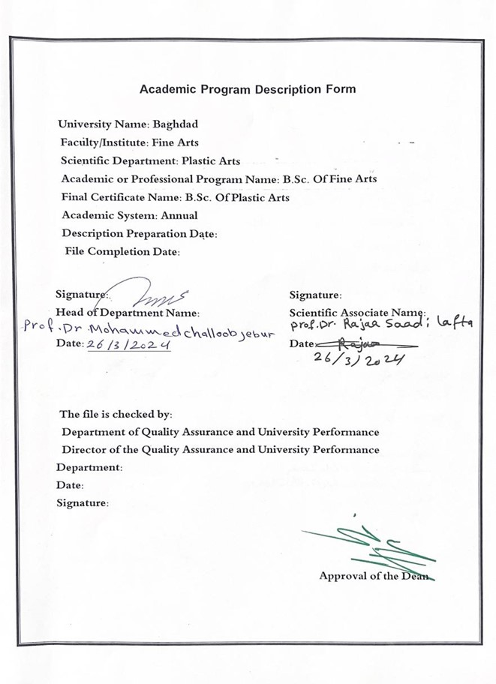

Approval of the Dean

- Program Vision
The college of fine Arts seeks to be one of the leading higher education institutions at the university of Baghdad in the field of modern education and scientific research through its scientific research administrative and applied activities it also work to provide an integrated path for its students and creative in serving the community in the artistic fields teaching them and mastering them.

- Program Mission
Working to prepare and graduate leading scientific leadership competencies in technical field in all its branches and to develop the balance of knowledge in the field of scientific research to serve the local regional and international community as well as training and refining the minds of students scientifically and cognitively emphasizing social and cultural values and responding to the requirements of loal market.

- Program Objectives
1-Embodying the vision and goals of the university of Baghdad and applying best education and practices with a focus on ensuring and enhancing quality and performance.
2-Preparing specialized cadres capable of serving the community in order to prepare future specializations.
3-Spreading the culture of hum and diversity in society transferring knowledge and technical skills writing academic research and creative scientific achievement through student and teaching focused activities.
4-Thecolley seeks to conclude scientific and culture cooperation agreements with corresponding college and corresponding departments in different colleges to achieve best practices in the technical fields.
5-Focusing on the educational and moral aspects of all its members and spreading the spirit of dedication tolerance commitment and work to serve the nation.
6-Interest in building thought and culture though openness to the experiences of other countries in all artistic fields.
7-Focusing on the educational and moral aspect of the student and spreading the spirit of dedication tolerance and commitment.

- Preparing Program Accreditation
No thing

- Other external influences
No thing

- Program Structure
Program Structure | Number of Courses | Credit hours | Percentage | Reviews*
Institution Requirements | 60 | 60 |  | Basic
College Requirements | yes
Department Requirements | yes
Summer Training | No thing
Other
* This can include notes whether the course is basic or optional.

- Program Description
Year/Level | Course Code | Course Name | Credit Hours
First/ 2023-2024 | Arabic language |  | theoretical | practical
 |  |  |  | 2

- Expected learning outcomes of the program
Knowledge
1-The student is familiar with the basics of Arabic language as well as its origins and development. | 2-Identify the parts of Arabic sentence accurately.  3-Identify the most prominent linguistic rules through which be can learn the basic of the language and practice correct pronunciation.
Ethics
1-Deveioping students abilities to share ideas and instill lofty values in them. | 2-Preparing the students for correct pronunciation regarding theatrical texts.
skills
1-Through his theoretical studies the student gains skills that qualify him to be able to pronounce the language.  2-The student acquires learning and knowing the language through hearing. | 3-Gaining the ability to write in the field of theater in sound of language.  4-Encouraing the students to be creative in the field he loves through language.

- Teaching and Learning Strategies
1-presenting the scientific material through explanation and clarification supported by examples and parsing.
2-use the surprise exam method of remind the students of the previous material.
3-Benefiting from by sending links to listen to specific verses from the holy Quran which develops their linguistc ability to avoid common mistakes.

- Evaluation methods
Surprise weekly exams that you have studied in previous subject quarterly exam and the end of year exam as well as interaction participation and discussion in the weekly lectures.

- Faculty
Faculty Members
Academic Rank | Specialization |  | Special Requirements/Skills (if applicable) |  | Number of the teaching staff
Academic Rank | General | Special |  |  | Staff | Lecturer
Assistant professor | Arabic language | Literature and rhetoric |  |  | Staff

Professional Development
Mentoring new faculty members
Assistance and guidance building to raise their level of scientific and ethical dealing with students as well as guiding them to access modern and valuable sources.

Professional development of faculty members
1-Continuous access to modern sources and follow – up of everything issued by reputable publishing houses.
2-Entry of faculty members into seminars and workshops in order to develop capabilities and scientific – level.
3-Cooperation and exchange of Ideas with professors and researchers at other universities.

- Acceptance Criterion
1-Central admission for morning study.
2-Direct admission for fine arts graduate.
3-Evening study for all scientific branches and is subdect to interview and selection.

- The most important sources of information about the program
The Holy Quran /explained by Ibn Aqeel/ Lisan al-Arab/ acollection of Arabic lessons and collections of the most prominent Iraqi and arab poets.

- Program Development Plan
1-Developing the program by reviewing the most prominent linguistic, grammatical and stylistic studies in the field of the Arabic poets.

2-Closely linking theater to the language in order to develop linguistic and vocal skills that serve the Artisticreality in academic study, which helps to spread this experience and make it model to be emulated.

Program Skills Outline
 |  |  |  | Required program Learning outcomes
Year/Level | Course Code | Course Name | Basic or optional | Knowledge |  |  |  | Skills |  |  |  | Ethics
 |  |  |  | A1 | A2 | A3 | A4 | B1 | B2 | B3 | B4 | C1 | C2 | C3 | C4
2023-2024 |  | Arabic language | Basic | A1 | A2 | A3 |  | B1 | B2 | B3 | B4 | C1 | C2

- Please tick the boxes corresponding to the individual program learning outcomes under evaluation.

S
Course Description Form
- Course Name:
Arabic language
- Course Code:
No thing
- Semester / Year:
Annual
- Description Preparation Date:
29/2/2024
- Available Attendance Forms:
Attendance only
- Number of Credit Hours (Total) / Number of Units (Total)
60 hours per year, 2 hours a work

- Course administrator's name (mention all, if more than one name)
Name: A .p Layla Abbas Khamis
Email: Layla.a@cofarts.uobaghdad.edu.iq

8.Course Objectives
1-Students acquire general principles in everything related to the Arabic language.

2-Develob the ability to correctly pronounce language in order to gain skill in scientific application.

3-Qualify the student to pronounce theatrical texts correctly.

9.Teaching and Learning Strategies
Strategy |  | 1-Teaching strategy through practical practice in language  Pronunciation.  2-Teaching Strategy Brainstorming.  3-Teaching Strategy series of notes This is done during lectures and  Open discussions to find out the mistakes and the development That the  Student has reached.
10.Course Structure
Week | Hours |  | Required Learning Outcomes | Unit or subject name |  |  | Learning method | Evaluation method
1  2  3  4  5  6  7  8  9  10  11  12  13  14  15  16  17  18  19  20  21  22  23  24  25  26  27  28  29  30 | 2  2  2  2  2  2  2  2  2  2  2  2  2  2  2  2  2  2  2  2  2  2  2  2  2  2  2  2  2  22 |  | 1-The student  Acquires the skill  In knowing the  Basics of the Arabic  Language  Grammatically  And  Morphologically.  2-knowing the  Parts of the Arabic  Sentence and the  Reason for the  Nominative  Accusative and  Genitive which  Reflects positively  On the applied  Study of texts.  3-tyaining in correct  Pronunciation  Knowing and  Correcting linguistic  Errors. | The past tense.  Types of artistic prose.  The imperative verb.  The short story.  Nominative of the  Present verb.  The art of novel.  The accusa five of the  Present verb.  The analysis of sermon  By Imam Ali (p. h).  The present tense verb.  The poet Abo tammam.  The subject.  The poet Al-Barikan.  The object.  The poet Al- mutanabbi.  The test of the end of the  Firs chapter.  The direct object.  The poet Al- sayyab.  The absolute object.  The poet Abo Atahiya.  The mubtadi.  The Number.  The New.  Predi cate interrogative.  Was and its sister.  That and its sister.  The Affirmalion.  The Exclamation.  The adjective.  Sub- scores and orginal  Marks.  End of second semester  Exam. |  |  | 1-delivering  Amini-lecture on what the  Students  Learned on what students  Learned in the  Previous week  And linking it  Sequentially  To the now  Subject.  2-explaning  The grammatical  And rhetorical  Material in  Detail supported by  Verses from  The holy  Quran and  Arabic poetry  3-Identifying  The poets  Designated  For study by  Addressing  Their lives  And the most  Prominent  Features of  There poetry  Supported by  Critical and  Analysis. | 1-Shors surprise  Written weekly  Exams.  2-Quarterly  Exams and  The end of  Year exam.  3-Preparing  Re ports  And mini-  Research  And  Discussing  Them by  Students.  4-Interaction  Participation  And  Discussion  In weekly  Lectures.
11.Course Evaluation
The distribution of grades is as follows. 25 marks of monthly and daily exams for the second old semester, so marks for final exams.

12.Learning and Teaching Resources
Required textbooks (curricular books, if any) |  |  |  |  | No Thing
Main references (sources) |  |  |  |  | The Holy Quran- Nahj al- Balgha, Ibn Ageel,s  Explanation –Lisan Al- arab – comprehensive  Grammar- collection of poets.
Recommended books and references (scientific journals, reports...) |  |  |  |  | Literatures and education magazines.
Electronic References, Websites |  |  |  |  | https://www.italki.com  https://www.mytutor,com  https://www.teacheron.com

