

Ministry of Higher Education and Scientific Research
Scientific supervision and evaluation device
Department of Quality Assurance and Academic Accreditation
Accreditation Department

Academic program and course description guide. Academic program and course description guide
دليل وصف البرنامج الأكاديمي والمقرر الدراسي

2024
the introduction:
The educational program is considered a coordinated and organized package of academic courses that includes procedures and experiences organized in the form of academic vocabulary, the main purpose of which is to build and refine the skills of graduates, making them qualified to meet the requirements of the labor market. It is reviewed and evaluated annually through internal or external audit procedures and programs such as the external examiner program.
The description of the academic program provides a brief summary of the main features of the program and its courses, indicating the skills that students are working to acquire based on the objectives of the academic program. The importance of this description is evident because it represents the cornerstone of obtaining program accreditation, and the teaching staff participates in writing it under the supervision of the scientific committees in the scientific departments.
This guide, in its second edition, includes a description of the academic program after updating the vocabulary and paragraphs of the previous guide in light of the latest developments in the educational system in Iraq, which included a description of the academic program in its traditional form (annual, quarterly), in addition to adopting the description of the academic program circulated according to the book of the Department of Studies, 3/2906. On 5/3/2023 with regard to programs that adopt the Bologna Process as a basis for their work.
In this area, we can only emphasize the importance of writing descriptions of academic programs and courses to ensure the smooth conduct of the educational process.

Concepts and terminology:

Description of the academic program : The description of the academic program provides a brief summary of its vision, mission, and goals, including an accurate description of the targeted learning outcomes according to specific learning strategies.
Course description : Provides a necessary summary of the most important characteristics of the course and the learning outcomes that the student is expected to achieve, demonstrating whether he has made the most of the available learning opportunities. It is derived from the program description.
Program Vision: An ambitious picture for the future of the academic program to be a developed, inspiring, motivating, realistic and applicable program.
The program's mission: It briefly explains the goals and activities necessary to achieve them, and also defines the program's development paths and directions.
Program objectives: These are statements that describe what the academic program intends to achieve within a specific period of time and are measurable and observable.
Curriculum structure: All courses/study subjects included in the academic program according to the approved learning system (semester, annual, Bologna track), whether it is a requirement (ministry, university, college, or scientific department), along with the number of study units.
Learning outcomes: A consistent set of knowledge, skills, and values that the student has acquired after the successful completion of the academic program. The learning outcomes for each course must be determined in a way that achieves the program objectives.
Teaching and learning strategies : They are the strategies used by the faculty member to develop the student’s teaching and learning, and they are plans that are followed to reach the learning goals. That is, it describes all curricular and extracurricular activities to achieve the learning outcomes of the programme.

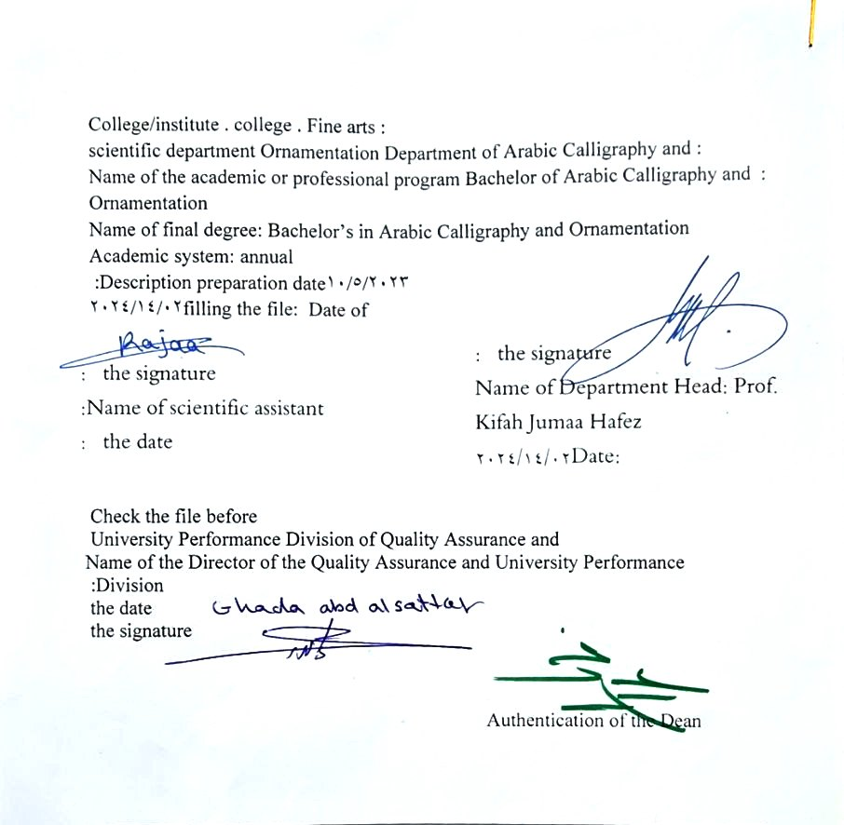

- See the program
The philosophy of the Department of Arabic Calligraphy and Ornamentation is based on achieving communication between originality and modernity, communication with the living heritage of Islamic art that has not exhausted its aesthetic and applied dimensions, and communication with cultural developments that will strengthen the creative thought of the arts of Arabic calligraphy and decoration, in addition to developing scientific capabilities by developing Students’ skills in this field are enriched, through the breadth of the educational and aesthetic experience and its openness to its counterparts in other universities in the world.

- Program message
Working to prepare and graduate leading scientific and leadership competencies in languages, sciences and literature, and to develop the balance of knowledge in the field of scientific research to serve the local, regional and international community, as well as training and refining the minds of students scientifically and cognitively, and emphasizing social and cultural values and responding to the requirements of the local market.

- Program Goals
1- Preparing academic and specialized calligraphers and decorators capable of implementing and presenting artistic projects in the arts of Arabic calligraphy and decoration, to meet the needs of the relevant state departments and the labor market, who hold a bachelor’s degree in the arts of Arabic calligraphy and decoration .
. 2- Preparing specialized researchers and artists with a high level of competence in the arts of Arabic calligraphy, decoration, and its aesthetics, for the purpose of contributing to the advancement of the artistic movement in Iraq and the Arab world, on objective foundations that rely on scientific research, experimentation, and committed art through graduate students .
3- Preparing the appropriate university-academic environment and climate for students to absorb the cognitive, skillful and emotional aspects of the arts of Arabic calligraphy and decoration, through curricular and extra-curricular activities and applied research studies that highlight the Arab heritage and embody the human meanings that the fine arts carry .
4- The department’s contribution to artistic activities and research projects at the level of the University of Baghdad and other Iraqi universities and at the level of relevant institutions, unions and artistic associations, in a way that serves the artistic process, scientific progress and the growing artistic awareness in Iraqi society .
5- Providing technical consultations in the arts of Arabic calligraphy and decoration to artistic institutions locally and internationally, in a way that serves and is consistent with the objectives of the department, relevant institutions and the development movement in our dear country .

- Program accreditation
nothing

- Other external influences
nothing

- Program structure
Program structure | Number of courses | Study unit | percentage | comments *
Enterprise requirements | 9 | 16 | 22.5% | Support decision
College requirements | 6 | 12 | 15% | Support decision
Department requirements | 26 | 52 | 65% | Basic course
summer training | nothing
Other
* Notes may include whether the course is core or elective.

- Program description
Year/level | Course or course code | Name of the course or course | Credit hours
the second | G2-9 | Vacation line | 4

- Expected learning outcomes of the programme
Knowledge
A- Cognitive objectives.
1a - To be able to do the following at the end of the chapter
2a- Knowledge and understanding of academic topics.
3a- Possessing clarity in the cognitive aspect in order to reach a high degree of sober scientific awareness.
4a- The student will acquire practical skills that will qualify him to study the applied aspect of calligraphy and decoration.
Skills
Learning outcomes 2 | The student acquires practical skills that qualify him to study the applied aspect of calligraphy and decoration
Learning outcomes 3 | - Knowledge and understanding of academic subjects  Possessing clarity in the cognitive aspect to reach a high degree of sober scientific awareness.
Value
Learning outcomes 4 | The student acquires personal skills at the level of the method required to be accomplished.
Learning outcomes 5 | Statement of learning outcomes 5  Learning through interpretation using means of illustration such as a smart board, computer, or display screen.

- Teaching and learning strategies
Learning through modeling using direct writing in front of the students and means of illustration such as the smart board, data show, computer, and display screen.

- Evaluation methods
Weekly, monthly, daily exams and the end of the year exam.

- education institution
Faculty members
Scientific rank | Specialization |  | Special requirements/skills (if any) |  | Preparing the teaching staff
Scientific rank | general | private |  |  | angel | lecturer
Mr | 1 | 1 |  |  | 2
Assistant Professor | 1 | 5 |  |  | 6
Teacher | 2 | 1 |  |  | 3
assistant teacher |  | 3 |  |  | 3 | 2

Professional development
Orienting new faculty members
Professional development for faculty members

- Acceptance standard
Special tests to reveal the talents of calligraphers and decorators

- The most important sources of information about the program
• Books
• Scientific research
Music library websites

- Program development plan
• By working to update the vocabulary for each year by 15%

Program skills chart
 |  |  |  | Learning outcomes required from the programme
Year / level | Course Code | Course Name | Essential or optional? | Knowledge |  |  |  | Skills |  |  |  | Value
 |  |  |  | A1 _ | A2 _ | A3 _ | A4 _ | B 1 | B2 _ | B3 _ | B4 _ | C1 _ | C 2 | C3 _ | C4 _
2023-2024 |  | Victorian and modern English poetry | Basic

- Please check the boxes corresponding to the individual learning outcomes from the program subject to evaluation

Course description form
- Course name : Bachelor’s degree
Victorian and modern English poetry
- Course Code : G2-8
- Semester / year : 2023-2024
Annual
- Date this description was prepared : 02/14/2024
- Available attendance forms : weekly
My presence only
- Number of study hours (total)/number of units (total):
90 hours annually . 3 hours per week

- Name of the course officer ( A.M.D. Kifah Jumah Hafez Sabr )
(Professor Dr. Kifah Jumah Hafez Sabr) Kefah.Hafez@cofarts.uobaghdad.edu.iq

- Course objectives
1. Through the subject’s vocabulary, students learn about the vacation line Of letters, their connections, and their words.  2. Students learn about the role of artists in this by studying their calligraphic methods  3. Students become familiar with linear structures and their types. |  |  |  |  |  | - ......  - ......  - ......
- Teaching and learning strategies
The strategy |  | 1- Teaching strategy : drawing letters and their connections .  2- Brainstorming education strategy.  3- Education Strategy Notes Series
- Course structure
the week | hours |  | Required learning outcomes | Name of the unit or topic |  |  | Learning method | Evaluation method
1  2  3  4  5  6  7  8  9  10  11  12  13  14  15  vacation  16  17  18  19  19  20  21  22  23  24  25  26  27  28  29  30 | 4 hour  4 hour  4 hour  4 hour  4 hour  4 hour  4 hour  4 hour  4 hour  4 hour  4 hour  4 hour  4 hour  4 hour  4 hour  4 hour  4 hour  4 hour  4 hour  4 hour  4 hour  4 hour  4 hour  4 hour  4 hour  4 hour  4 hour  4 hour  4 hour  4 hour  4 hour |  | 1- Practicing the Arabic letters in separate and connected Ijaza script, inflectional and ornamental vowels, writing a group of blessed Qur’anic verses, noble Prophetic hadiths, some wisdom and sayings, and simulating a painting in Ijaza script. | Vacation line |  |  | 1. Handwriting of single letters in the Baghdadi style, based on the booklet of the late Hashim Muhammad Al-Baghdadi.  2. Assigning students to write them in special, approved notebooks, inspect them, and make notes on them as a class assignment.  3. Assigning students a homework assignment by writing a set of letters, words, and lines.  4. Imitating an artistic painting in Ijaza script. | Weekly, monthly, daily, practical and end-of-year exams .
- Course evaluation
Distribution of the score out of 100 according to the tasks assigned to the student, such as daily preparation, daily, monthly, and applied exams...etc.
- Learning and teaching resources
Required textbooks (methodology, if any) |  |  |  |  | The approved booklet by the calligrapher Hashim Muhammad al-Baghdadi, and the perfect lines in the Ijaza script in other sources.
Main references (sources) |  |  |  |  | The approved brochure by the calligrapher Hashim Muhammad al-Baghdadi
Recommended supporting books and references (scientific journals, reports....) |  |  |  |  | Perfect fonts in Ijaza script in other sources.
Electronic references, Internet sites |  |  |  |  | https://zlibrary-asia.se/  https://www.researchgate.net/

