
Ministry of Higher Education and Scientific Research
Scientific supervision and evaluation device
Department of Quality Assurance and Academic Accreditation
Accreditation Department

Academic program and course description guide. Academic program and course description guide

Academic program and course description guide

2024
the introduction:
The educational program is considered a coordinated and organized package of academic courses that includes procedures and experiences organized in the form of academic vocabulary, the main purpose of which is to build and refine the skills of graduates, making them qualified to meet the requirements of the labor market. It is reviewed and evaluated annually through internal or external audit procedures and programs such as the external examiner program.
The description of the academic program provides a brief summary of the main features of the program and its courses, indicating the skills that students are working to acquire based on the objectives of the academic program. The importance of this description is evident because it represents the cornerstone of obtaining program accreditation, and the teaching staff participates in writing it under the supervision of the scientific committees in the scientific departments.
This guide, in its second edition, includes a description of the academic program after updating the vocabulary and paragraphs of the previous guide in light of the latest developments in the educational system in Iraq, which included a description of the academic program in its traditional form (annual, quarterly), in addition to adopting the description of the academic program circulated according to the book of the Department of Studies 3/2906. On 5/3/2023 with regard to programs that adopt the Bologna Process as a basis for their work.
In this area, we can only emphasize the importance of writing descriptions of academic programs and courses to ensure the smooth conduct of the educational process.

Concepts and terminology:

Description of the academic program : The description of the academic program provides a brief summary of its vision, mission, and goals, including an accurate description of the targeted learning outcomes according to specific learning strategies.
Course Description : Provides a necessary summary of the most important characteristics of the course and the learning outcomes expected of the student to achieve, demonstrating whether he or she has made the most of the available learning opportunities. It is derived from the program description.
Program Vision: An ambitious picture for the future of the academic program to be a developed, inspiring, motivating, realistic and applicable program.
The program's mission: It briefly explains the goals and activities necessary to achieve them, and also defines the program's development paths and directions.
Program objectives: These are statements that describe what the academic program intends to achieve within a specific period of time and are measurable and observable.
Curriculum structure: All courses/study subjects included in the academic program according to the approved learning system (semester, annual, Bologna track), whether it is a requirement (ministry, university, college, or scientific department), along with the number of study units.
Learning outcomes: A consistent set of knowledge, skills, and values that the student has acquired after the successful completion of the academic program. The learning outcomes for each course must be determined in a way that achieves the program objectives.
Teaching and learning strategies : They are the strategies used by the faculty member to develop the student’s teaching and learning, and they are plans that are followed to reach the learning goals. That is, it describes all curricular and extracurricular activities to achieve the learning outcomes of the programme.

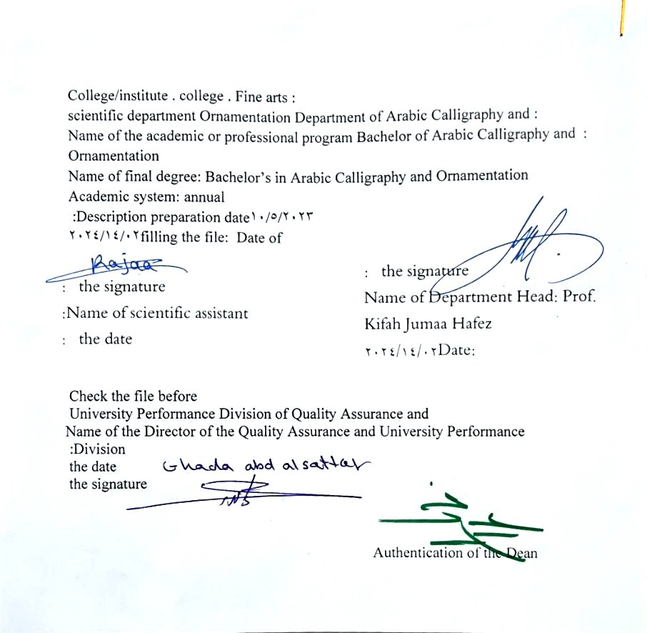

- See the program
The philosophy of the Department of Arabic Calligraphy and Ornamentation is based on achieving communication between originality and contemporaneity, communication with the living heritage of Islamic art that has not exhausted its aesthetic and applied dimensions, and communication with cultural developments that will strengthen the creative thought of the arts of Arabic calligraphy and decoration, in addition to developing scientific capabilities by developing Students’ skills in this field are enriched, through the breadth of the educational and aesthetic experience and its openness to its counterparts in other universities in the world.

- Program message
Working to prepare and graduate leading scientific and leadership competencies in languages, sciences and literature, and to develop the balance of knowledge in the field of scientific research to serve the local, regional and international community, as well as training and refining the minds of students scientifically and cognitively, and emphasizing social and cultural values and responding to the requirements of the local market.

- Program Goals
1- Preparing academic and specialized calligraphers and decorators capable of implementing and presenting artistic projects in the arts of Arabic calligraphy and decoration, to meet the needs of the relevant state departments and the labor market, who hold a bachelor’s degree in the arts of Arabic calligraphy and decoration .
. 2- Preparing specialized researchers and artists with a high level of competence in the arts of Arabic calligraphy, decoration, and its aesthetics, for the purpose of contributing to the advancement of the artistic movement in Iraq and the Arab world, on objective foundations that rely on scientific research, experimentation, and committed art through graduate students .
3- Preparing the appropriate university-academic environment and climate for students to absorb the cognitive, skillful and emotional aspects of the arts of Arabic calligraphy and decoration, through curricular and extra-curricular activities and applied research studies that highlight the Arab heritage and embody the human meanings that the fine arts carry .
4- The department’s contribution to artistic activities and research projects at the level of the University of Baghdad and other Iraqi universities and at the level of relevant institutions, unions and artistic associations, in a way that serves the artistic process, scientific progress and the growing artistic awareness in Iraqi society .
5- Providing technical consultations in the arts of Arabic calligraphy and decoration to artistic institutions locally and internationally, in a way that serves and is consistent with the objectives of the department, relevant institutions and the development movement in our dear country .

- Program accreditation
nothing

- Other external influences
nothing

- Program structure
Program structure | Number of courses | Study unit | percentage | comments *
Enterprise requirements | 9 | 16 | 22.5% | Support decision
College requirements | 6 | 12 | 15% | Support decision
Department requirements | 26 | 52 | 65% | Basic course
summer training | nothing
Other
* Notes may include whether the course is core or elective.

- Program description
Year/level | Course or course code | Name of the course or course | Credit hours

- Expected learning outcomes of the programme
Knowledge
A- Cognitive objectives.
1a - To be able to do the following at the end of the chapter
2 A- Knowledge and understanding of academic topics.
3a- Having clarity in the cognitive aspect in order to reach a high degree of sober scientific awareness.
4 A- The student will acquire practical skills that will qualify him to study the applied aspect of designing and printing typefaces.
B - Skills objectives of the program:
B1: The student acquires the intellectual cognitive skills required to be achieved.
B2 The student acquires the practical skills required to be accomplished.
B3: The student acquires personal skills at the level of the method required to be accomplished.
Skills
Expanding the student’s practical performance skills
Value
Developing students’ abilities to share ideas
Developing students' intellectual capabilities And expanding its flexibility in devising and designing typographic characters

- Teaching and learning strategies
1- Explaining the scientific material through modeling and direct drawing on the blackboard and paper
2- The student performs the skills he learned during the lesson to diagnose, evaluate and develop his abilities during the lectures.
3- Giving the student an assignment to practice that includes applying an axis of what he learned in the lesson in terms of design and organization to achieve feedback.

- Evaluation methods
Weekly, monthly, daily exams and the end of the year exam.

- education institution
Faculty members
Scientific rank | Specialization |  | Special requirements/skills (if any) |  | Preparing the teaching staff
Scientific rank | general | private |  |  | angel | lecturer
Mr | 1 | 1 |  |  | 2
Assistant Professor | 1 | 5 |  |  | 6
Teacher | 2 | 1 |  |  | 3
assistant teacher |  | 3 |  |  | 3 | 2

Professional development
Orienting new faculty members
Professional development for faculty members

- Acceptance standard

- The most important sources of information about the program
- Textbooks and methodologies approved by the Scientific Committee and the Academic and Accreditation Committees.
- B- Archived lectures in the form of transcripts by the specialty teachers for each subject
C- Internet sites

- Program development plan
Study of all types of printing and how to implement each printing technique
Work to develop the student’s abilities in design and typographical organization methods

Program skills chart
 |  |  |  | Learning outcomes required from the programme
Year / level | Course Code | Course Name | Essential or optional? | Knowledge |  |  |  | Skills |  |  |  | Value
 |  |  |  | A1​ | A2​ | A3​ | A4​ | B 1 | B2​ | B3​ | B4​ | C1​ | C 2 | C3​ | C4​
2023-2024 |  | Typographic letter | Basic

- Please check the boxes corresponding to the individual learning outcomes from the program subject to evaluation

Course description form
- Course name : Typography
- Course Code :
- Semester / Year : Annual
Annual
- Date this description was prepared : 02/14/2024
- Available forms of attendance :
My presence only
- Number of study hours (total)/number of units (total):
90 hours annually . 3 hours per week

- Name of the course administrator (if more than one name is mentioned)
Name : Ashraf Kamel Abdel Amir Email : Ashraf.K.342@cofarts.uobaghdad.edu.iq
.

- Course objectives
1- Providing students with skills in designing and printing typefaces.  Drawing vocabulary typographic letter  2 - Developing the student’s performance capabilities in methods for different spaces. 3 - Clarifying the most important theoretical and practical ideas and concepts and their applications to find new uses for the student. |  |  |  |  |  | - ......  - ......  - ......
- Teaching and learning strategies
The strategy |  | 1- Educational strategy, collaborative concept planning.  2- Brainstorming education strategy.  3- Education Strategy Notes Series
- Course structure
the week | hours |  | Required learning outcomes | Name of the unit or topic |  |  | Learning method | Evaluation method
1  2  3  4  5  6  7  8  9  10  11  12  13  14  15  vacation  16  17  18  19  19  20  21  22  23  24  25  26  27  28  29  30 | 3 hours  3 hours  3 hours  3 hours  3 hours  3 hours  3 hours  3 hours  3 hours  3 hours  3 hours  3 hours  3 hours  3 hours  3 hours  3 hours  3 hours  3 hours  3 hours  3 hours  3 hours  3 hours  3 hours  3 hours  3 hours  3 hours  3 hours  3 hours  3 hours  3 hours  3 hours |  | 1- Providing students with the skill of drawing typography. 2- Informing students about the importance of typography, its variations and applications.  3- The ability to know the types of printing in accordance with the requirements for completing different works |  |  |  | Explaining scientific material through modeling and direct drawing on the blackboard and paper  2- The student performs the skills he learned during the lesson to diagnose, evaluate and develop his abilities during the lectures.  3- Giving the student an assignment to practice that includes applying an axis of what he learned in the lesson in terms of the written type to achieve feedback. | Weekly, monthly, daily, written exams, and the end-of-year exam .
- Course evaluation
Distribution is as follows : 50 Score of monthly and daily exams for the first semester . 50 Score of monthly and daily exams for the second semester . 50 marks for final exams
- Learning and teaching resources
Required textbooks (methodology, if any)
Main references (sources) |  |  |  |  | Functional and aesthetic dimensions in commercial advertising design/Salam Hameed  Constructivism of the design idea of the printed work / Ibrahim Hamdan
Recommended supporting books and references (scientific journals, reports....) |  |  |  |  | Academic magazine  Arabic letters magazine
Electronic references, Internet sites |  |  |  |  | Arabic Calligraphy Portal  Creators Network

