Ministry of Higher Education and Scientific Research
Scientific supervision and evaluation device
Department of Quality Assurance and Academic Accreditation

Accreditation Department

Academic Program Description Guide Description of the academic program and course
Academic program and course description guide

2024
the introduction:

The educational program is considered a coordinated and organized package of academic courses that includes procedures and experiences organized in the form of academic vocabulary, the main purpose of which is to build and refine the skills of graduates, making them qualified to meet the requirements of the labor market. It is reviewed and evaluated annually through internal or external audit procedures and programs such as the external examiner program.
The description of the academic program provides a brief summary of the main features of the program and its courses, indicating the skills that students are working to acquire based on the objectives of the academic program. The importance of this description is evident because it represents the cornerstone of obtaining program accreditation, and the teaching staff participates in writing it under the supervision of the scientific committees in the scientific departments.
This guide, in its second edition, includes a description of the academic program after updating the vocabulary and paragraphs of the previous guide in light of the latest developments in the educational system in Iraq, which included a description of the academic program in its traditional form (annual, quarterly), in addition to adopting the description of the academic program circulated according to the book of the Department of Studie On with regard to programs that adopt the Bologna Process as a basis for their work.
In this area, we can only emphasize the importance of writing descriptions of academic programs and courses to ensure the smooth conduct of the educational process.

Concepts and terminology
Description of the academic program : The description of the academic program provides a brief summary of its vision, mission, and goals, including an accurate description of the targeted learning outcomes according to specific learning strategies.
Course description : Provides a necessary summary of the most important characteristics of the course and the learning outcomes that the student is expected to achieve, demonstrating whether he has made the most of the available learning opportunities. It is derived from the program description.
Program Vision: An ambitious picture for the future of the academic program to be a developed, inspiring, motivating, realistic and applicable program.
The program's mission: It briefly explains the goals and activities necessary to achieve them, and also defines the program's development paths and directions.
Program objectives: These are statements that describe what the academic program intends to achieve within a specific period of time and are measurable and observable.
Curriculum structure: All courses/study subjects included in the academic program according to the approved learning system (semester, annual, Bologna track), whether it is a requirement (ministry, university, college, or scientific department), along with the number of study units.
Learning outcomes: A consistent set of knowledge, skills, and values that the student has acquired after the successful completion of the academic program. The learning outcomes for each course must be determined in a way that achieves the program objectives.
Teaching and learning strategies : They are the strategies used by the faculty member to develop the student’s teaching and learning, and they are plans that are followed to reach the learning goals. That is, it describes all curricular and extracurricular activities to achieve the learning outcomes of the programme.

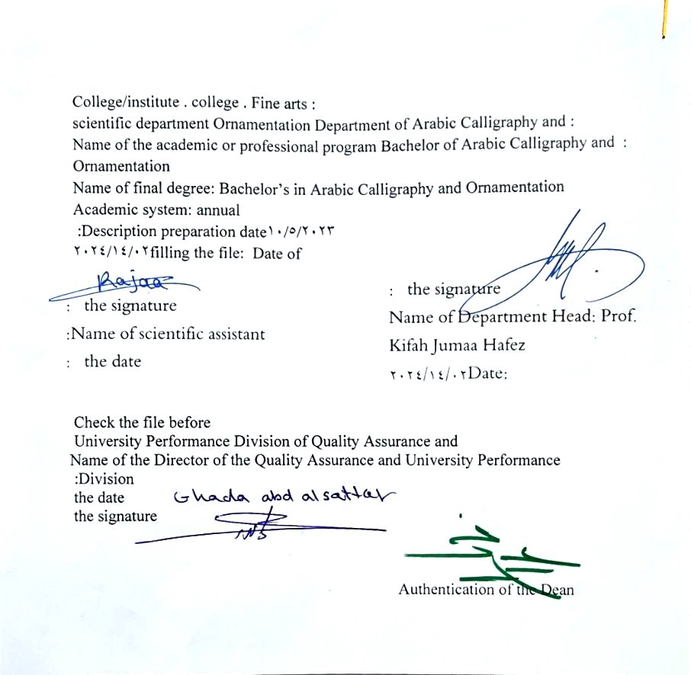

- See the program
The philosophy of the Department of Arabic Calligraphy and Ornamentation is based on achieving communication between originality and modernity, communication with the living heritage of Islamic art that has not exhausted its aesthetic and applied dimensions, and communication with cultural developments that will strengthen the creative thought of the arts of Arabic calligraphy and decoration, in addition to developing scientific capabilities by developing skills. Students in this rich field, through the breadth of the educational and aesthetic experience and its openness to its counterparts in other universities in the world.

- Program message
Working to prepare and graduate leading scientific and leadership competencies in languages, sciences and literature, and to develop the balance of knowledge in the field of scientific research to serve the local, regional and international community, as well as training and refining the minds of students scientifically and cognitively, and emphasizing social and cultural values and responding to the requirements of the local market.

- Program Goals
- Preparing academic and specialized calligraphers and decorators capable of implementing and presenting artistic projects in the arts of Arabic calligraphy and decoration, to meet the needs of the relevant state departments and the labor market. They hold a bachelor’s degree in the arts of Arabic calligraphy and decoration.
- Preparing specialized researchers and artists with a high level of competence in the arts of Arabic calligraphy, decoration, and its aesthetics, for the purpose of contributing to the advancement of the artistic movement in Iraq and the Arab world, on objective foundations that rely on scientific research, experimentation, and committed art through graduate students.
- Preparing the appropriate university-academic environment and climate for students to absorb the cognitive, skillful and emotional aspects of the arts of Arabic calligraphy and decoration, through curricular and extra-curricular activities and applied research studies that highlight the Arab heritage and embody the human meanings that the fine arts carry.
- The department’s contribution to artistic activities and research projects at the level of the University of Baghdad and other Iraqi universities and at the level of relevant institutions, unions and artistic associations, in a way that serves the artistic process, scientific progress and the growing artistic awareness in Iraqi society.
- Providing technical consultations in the arts of Arabic calligraphy and decoration to artistic institutions locally and internationally, in a way that serves and is consistent with the objectives of the department, related institutions and the development movement in our dear country.

- Program accreditation
nothing
- Other external influences
nothing

- Program structure
Program structure | Number of courses | Study unit | percentage | comments *
Enterprise requirements | 9 | 16 | 22.5% | Support decision
College requirements | 6 | 12 | 15% | Support decision
Department requirements | 26 | 52 | 65% | Basic course
summer training | nothing
Other
- Program description
Year/level | Course or course code | Name of the course or course | Credit hours
fourth grade | G4-6 | Thuluth line | practical | theoretical
 |  |  | 4 | -
* Notes may include whether the course is core or elective.

- Expected learning outcomes of the programme
Knowledge
- Cognitive goals | A1- Introducing the history of the Thuluth script, its origins, and its development over time.  A2- Introducing the technical schools and the implementation materials and techniques they produced.  A3- Explaining the influence of the Thuluth script on the contemporary arts that inspired it.
Skills
- Program specific skill objectives | B1- Providing students with the cognitive and intellectual skills required to be achieved.  B2- Providing students with the practical skills required to be accomplished.  B 3- Providing students with personal skills at the level of the method required to be accomplished.  B4 Providing students with practical skills that qualify them to perform the applied aspect of painting.
Value
Developing students’ abilities to share ideas
Students’ ability to know the styles of Thuluth script
- Teaching and learning strategies
- Modeling .
- Simulation of known linear plates in a linear medium.

- Evaluation methods
Daily, monthly and final student tests, as well as evaluating classroom exercises and homework costs

- education institution
Faculty members
Scientific rank | Specialization |  | Special requirements/skills (if any) |  | Preparing the teaching staff
Scientific rank | general | private |  |  | angel | lecturer
Mr | 1 | 1 |  |  | 2
Assistant Professor | 1 | 5 |  |  | 6
Teacher | 2 | 1 |  |  | 3
assistant teacher |  | 5 |  |  | 3 | 2

Professional development
Orienting new faculty members
Briefly describes the process used to orient new, visiting, full-time, and part-time faculty at the institution and department levels.
Professional development for faculty members
Briefly describe the academic and professional development plan and arrangements for faculty members such as teaching and learning strategies, assessment of learning outcomes, professional development, etc.

- Acceptance standard
Special tests to reveal artistic and academic talents

- The most important sources of information about the program
the reviewer
Specialized books
University theses and dissertations
Scientific research
Internet sites specialized in the art of decoration

- Program development plan
- By working to update the vocabulary each year by 15%.

Program skills chart
Learning outcomes required from the programme
Year/level | Course Code | Course Name | Essential or optional? | Knowledge |  |  |  | Skills |  |  |  | Value
 |  |  |  | A1 _ | A2 _ | A3 _ | A4 _ | B 1 | B2 _ | B3 _ | B4 _ | C1 _ | C 2 | C3 _ | C4 _
2023 - 2024  fourth level | G4-6 | Thuluth line | Basic

- Please check the boxes corresponding to the individual learning outcomes from the program subject to evaluation

Course description form
- Course Name :
Thuluth line
- Course Code:
G 4-6
- Semester/year
Annual
- Date this description was prepared :
14/2/2024
- Available forms of attendance :
My presence only
- Number of study hours (total)/number of units (total):
120 hours annually. 4 hours per week /2 units
- Name of the course administrator (if more than one name is mentioned)
Name: M. Dr.. Ali Abdul Hussein Mohsen Contact : ali.a@cofarts.uobaghdad.edu.iq _ _
- Course objectives
- Teaching fourth grade students the foundations and principles of Thuluth calligraphy and the artistic components it requires in the initial stages of formation through the final completion stage.  - Teaching fourth grade students the basics of Thuluth script, as well as the technical skills in writing its lines.  - Contributing to spreading artistic awareness regarding the Thuluth script and reaching the values of artistic creativity. |  |  |  |  |  |  |  |  |  |  | - ......  - ......  - ......
- Teaching and learning strategies
The strategy |  |  | - Education strategy collaborative concept planning By seeking help from foreign professors to deliver lectures  The department and college and twinning work with international colleges and universities  - Teaching strategy brainstorming.  - Education strategy notes series
- Course structure
the week |  | hours |  |  | Required learning outcomes |  | Name of the unit or topic |  |  | Learning method |  |  | Evaluation method
1 | 4 hours |  |  | The student’s ability to know the topic studied each week |  | A comparative study between types of Arabic calligraphy |  |  | Through drills and exercises on the blackboard and on glossy paper |  |  | Monthly and daily examinations
2 | 4 hours |  |  |  |  | Introduction to the Thuluth script, its characteristics, reasons for naming it, and its functional, aesthetic, and semantic meanings
3 | 4 hours |  |  |  |  | An applied study of the rules of separate letters (a, b, c, d)
4 | 4 hours |  |  |  |  | Completing the study of the rules for the different types of letters “Ra” and “Seen” with its different types
5 | 4 hours |  |  |  |  | Completing the study of the rules of the letters (sa, ta, a)
6 | 4 hours |  |  |  |  | Completing the study of the rules of the letters (F, Q, K)
7 | 4 hours |  |  |  |  | Completing the study of the rules of letters (L, M, N)
8 | 4 hours |  |  |  |  | Completing the study of the rules of letters (wa, ha, la, y)
9 | 4 hours |  |  |  |  | Study the connections of the ba with other letters
10 | 4 hours |  |  |  |  | Study the connections of the ha with other letters
11 | 4 hours |  |  |  |  | Study the connections of sīn with other letters
12 | 4 hours |  |  |  |  | Study the connections of the ṣad and ṭā’ with other letters
13 | 4 hours |  |  |  |  | Study eye contacts with other letters
14 | 4 hours |  |  |  |  | Study the connections of the kaf and lam with other letters
15 | 4 hours |  |  |  |  | Showing examples of the most famous calligraphers
16 | 4 hours |  |  |  |  | Mid-year exam
vacation |  |  |  | The student’s ability to know the topic studied each week |  |  |  |  | Through drills and exercises on the blackboard and on glossy paper |  |  | Monthly and daily examinations
17 | 4 hours |  |  |  |  | Study of formations, decorative signs, and parsing movements
18 | 4 hours |  |  |  |  | Study of the Basmala
19 | 4 hours |  |  |  |  | Study (Praise be to God, Lord of the Worlds)
20 |  |  |  |  |  | Study (The Most Gracious, the Most Merciful, Malik on the Day of Judgment)
21 |  |  |  |  |  | Study (You we count and You we seek help)
22 |  |  |  |  |  | Study (Guide us to the straight path)
23 |  |  |  |  |  | Study (The path of those whom You have bestowed)
24 |  |  |  |  |  | Study of (Those who are not angry or who go astray)
25 |  |  |  |  |  | Study of technical and implementation methods in Thuluth script
26 |  |  |  |  |  | Study of light composition on the line
27 |  |  |  |  |  | Two-level composition study
28 |  |  |  |  |  | Study of heavy composition
29 |  |  |  |  |  | Study some geometric structures
30 |  |  |  |  |  | Practical exam at the end of the year
- Course evaluation
Distribution is as follows: 50 marks for the first half year / 50 marks for the second half year
- Learning and teaching resources
Required textbooks (methodology, if any)
Main references (sources)
Recommended supporting books and references (scientific journals, reports....)
Electronic references, Internet sites

