
Ministry of Higher Education and Scientific Research
Scientific supervision and evaluation device
Department of Quality Assurance and Academic Accreditation
Accreditation Department
description guide

the introduction:

Academic program and course 2024

The educational program is considered a coordinated and organized package of academic courses that includes procedures and experiences organized in the form of academic vocabulary, the main purpose of which is to build and refine the skills of graduates, making them qualified to meet the requirements of the labor market. It is reviewed and evaluated annually through internal or external audit procedures and programs such as the external examiner program.
The description of the academic program provides a brief summary of the main features of the program and its courses, indicating the skills that students are working to acquire based on the objectives of the academic program. The importance of this description is evident because it represents the cornerstone of obtaining program accreditation, and the teaching staff participates in writing it under the supervision of the scientific committees in the scientific departments.
This guide, in its second edition, includes a description of the academic program after updating the vocabulary and paragraphs of the previous guide in light of the latest developments in the educational system in Iraq, which included a description of the academic program in its traditional form (annual, quarterly), in addition to adopting the description of the academic program circulated according to the book of the Department of Studies 3/2906. On 5/3/2023 with regard to programs that adopt the Bologna Process as a basis for their work.
In this area, we can only emphasize the importance of writing descriptions of academic programs and courses to ensure the smooth conduct of the educational process.

Concepts and terminology:

Description of the academic program : The description of the academic program provides a brief summary of its vision, mission, and goals, including an accurate description of the targeted learning outcomes according to specific learning strategies.
Course Description : Provides a necessary summary of the most important characteristics of the course and the learning outcomes expected of the student to achieve, demonstrating whether he or she has made the most of the available learning opportunities. It is derived from the program description.
Program Vision: An ambitious picture for the future of the academic program to be a developed, inspiring, motivating, realistic and applicable program.
The program's mission: It briefly explains the goals and activities necessary to achieve them, and also defines the program's development paths and directions.
Program objectives: These are statements that describe what the academic program intends to achieve within a specific period of time and are measurable and observable.
Curriculum structure: All courses/study subjects included in the academic program according to the approved learning system (semester, annual, Bologna track), whether it is a requirement (ministry, university, college, or scientific department), along with the number of study units.
Learning outcomes: A consistent set of knowledge, skills, and values that the student has acquired after the successful completion of the academic program. The learning outcomes for each course must be determined in a way that achieves the program objectives.
Teaching and learning strategies : They are the strategies used by the faculty member to develop the student’s teaching and learning, and they are plans that are followed to reach the learning goals. That is, it describes all curricular and extracurricular activities to achieve the learning outcomes of the programme.

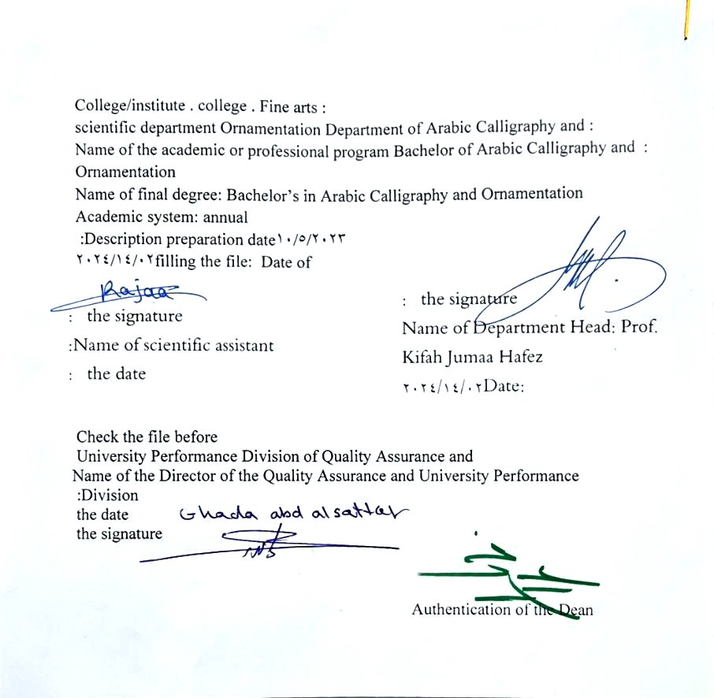

- See the program
The philosophy of the Department of Arabic Calligraphy and Ornamentation is based on achieving communication between originality and contemporaneity, communication with the living heritage of Islamic art that has not exhausted its aesthetic and applied dimensions, and communication with cultural developments that will strengthen the creative thought of the arts of Arabic calligraphy and decoration, in addition to developing scientific capabilities by developing Students’ skills in this field are enriched , through the breadth of the educational and aesthetic experience and its openness to its counterparts in other universities in the world.

- Program message
Working to prepare and graduate leading scientific and leadership competencies in languages, sciences and literature, and to develop the balance of knowledge in the field of scientific research to serve the local, regional and international community, as well as training and refining the minds of students scientifically and cognitively, and emphasizing social and cultural values and responding to the requirements of the local market.

- Program Goals
1- Preparing academic and specialized calligraphers and decorators capable of implementing and presenting artistic projects in the arts of Arabic calligraphy and decoration, to meet the needs of the relevant state departments and the labor market, who hold a bachelor’s degree in the arts of Arabic calligraphy and decoration .
. 2- Preparing specialized researchers and artists with a high level of competence in the arts of Arabic calligraphy, decoration, and its aesthetics, for the purpose of contributing to the advancement of the artistic movement in Iraq and the Arab world, on objective foundations that rely on scientific research, experimentation, and committed art through graduate students .
3- Preparing the appropriate university-academic environment and climate for students to absorb the cognitive, skillful and emotional aspects of the arts of Arabic calligraphy and decoration, through curricular and extra-curricular activities and applied research studies that highlight the Arab heritage and embody the human meanings that the fine arts carry .
4- The department’s contribution to artistic activities and research projects at the level of the University of Baghdad and other Iraqi universities and at the level of relevant institutions, unions and artistic associations, in a way that serves the artistic process, scientific progress and the growing artistic awareness in Iraqi society .
5- Providing technical consultations in the arts of Arabic calligraphy and decoration to artistic institutions locally and internationally, in a way that serves and is consistent with the objectives of the department, relevant institutions and the development movement in our dear country .

- Program accreditation
nothing

- Other external influences
nothing

- Program structure
Program structure | Number of courses | Study unit | percentage | comments *
Enterprise requirements | 9 | 16 | 22.5% | Support decision
College requirements | 6 | 12 | 15% | Support decision
Department requirements | 26 | 52 | 65% | Basic course
summer training | nothing
Other
* Notes may include whether the course is core or elective.

- Program description
Year/level | Course or course code | Name of the course or course | Credit hours
fourth grade | G4-3 | Simulation | 2 | 1

- Expected learning outcomes of the programme
Knowledge
Cognitive goals | A - To be able to do the following at the end of the chapter  2a- Knowing and understanding how to simulate linear composition and decorative composition.  3a- Possessing clarity in the cognitive aspect in order to reach a high degree of sober scientific and artistic awareness .  4a- Students acquire practical skills that qualify them to perform the academic- technical aspect of simulating the achievement.
Skills
B - Skills objectives of the program: | B1 : Providing students with the required intellectual cognitive skills and employing them in simulating calligraphic decorative painting.  B2 Providing students with practical and artistic skills in tools (calligraphy and decoration) to reach the achievement.  B3: The student acquires personal skills at the level of the method required to be accomplished.
Value
Developing students’ abilities to share ideas
Students’ ability to know the types and methods of simulation

- Teaching and learning strategies
Learning how to imitate the artistic achievements of the greatest calligraphers and decorators according to the design visions and producing creative artistic achievements bearing old styles with new direction.

- Evaluation methods
Daily, monthly and final student tests, as well as evaluating classroom exercises and home costs

- education institution
Faculty members
Scientific rank | Specialization |  | Special requirements/skills (if any) |  | Preparing the teaching staff
Scientific rank | general | private |  |  | angel | lecturer
Mr | 1 | 1 |  |  | 2
Assistant Professor | 1 | 5 |  |  | 6
Teacher | 2 | 1 |  |  | 3
assistant teacher |  | 5 |  |  | 3 | 2

Professional development
Orienting new faculty members
Briefly describes the process used to orient new, visiting, full-time, and part-time faculty at the institution and department levels.
Professional development for faculty members
Briefly describe the academic and professional development plan and arrangements for faculty members such as teaching and learning strategies, assessment of learning outcomes, professional development, etc.

- Acceptance standard
Special tests to uncover artistic and academic talents

- The most important sources of information about the program
the reviewer
Books
Messages and theses
Scientific research
Library websites dedicated to calligraphy and decoration technicians

- Program development plan
- By working to update the vocabulary each year by 15%.

Program skills chart
 |  |  |  | Learning outcomes required from the programme
Year / level | Course Code | Course Name | Essential or optional? | Knowledge |  |  |  | Skills |  |  |  | Value
 |  |  |  | A1​ | A2​ | A3​ | A4​ | B 1 | B2​ | B3​ | B4​ | C1​ | C 2 | C3​ | C4​
fourth grade | G4-3 | Simulation | Basic

- Please check the boxes corresponding to the individual learning outcomes from the program subject to evaluation

Course description form
- Course Name :
Simulation
- Course Code :
G4-3
- Semester / year
Annual
- Date this description was prepared :
02/14/2024
- Available forms of attendance :
My presence only
- Number of study hours (total)/number of units (total):
90 hours annually . 3 hours per week /2 units

- Name of the course administrator (if more than one name is mentioned)
Name : M.M. Aram Muhammad Hussein Email : aram.m@cofarts.uobaghdad.edu.iq

- Course objectives
C1 Observation, understanding, and interpretation of the course material.  C2 The ability to analyse, deduce, evaluate, and issue judgment.  C3: Deduction, measurement, and interpretation of the details of the course. |  |  |  |  |  | - ......  - ......  - ......
- Teaching and learning strategies
The strategy |  | - Education strategy: Planning the cooperative concept by seeking the help of foreign professors to deliver lectures in  The department and college and twinning work with international colleges and universities  2- Brainstorming education strategy.  3- Education Strategy Notes Series
- Course structure
the week | hours |  | Required learning outcomes | Name of the unit or topic |  |  | Learning method | Evaluation method
1  2  3  4  5  6  7  8  9  10  11  12  13  14  15  vacation  16  17  18  19  19  20  21  22  23  24  25  26  27  28  29  30 | 3 hours  3 hours  3 hours  3 hours  3 hours  3 hours  3 hours  3 hours  3 hours  3 hours  3 hours  3 hours  3 hours  3 hours  3 hours  3 hours  3 hours  3 hours  3 hours  3 hours  3 hours  3 hours  3 hours  3 hours  3 hours  3 hours  3 hours  3 hours  3 hours  3 hours  3 hours |  | The student’s ability to know the topic studied each week | Preliminary studies/fourth grade  practical  2  4  1 Introducing the simulation objectives  2 Initial settings for the simulation idea  3Display calligraphic and decorative models for a number of  4 Calligraphers (pioneers and others)  5 simulation techniques  6 Choose basic models  7 Patch line simulation  8 First mid-semester exam  9Simulation in Kufi script  11 Imitation in Diwani script  12 Imitations in Diwani Jali script (composition)  13 Introducing the objectives of simulation (vegetal and geometric decorations)  41Display various decorative models for different decorative panels Multifunctional  15 selection of basic models  16 Simulation decorative strip  17 decorative simulation of patchwork painting  18 Second midterm exam  19 decorative simulations of the painting (The Noble Prophet’s Ornament).  20 A continuation of the previous week's simulation  21 Complete the solution simulation  23 Simulation of geometric decorations (definition and presentation of models)  24 Simulation of geometric motifs (star-shaped)  25 Imitation in Diwani Jali script (strip composition) 27  26 simulation in Naskh script  27 Imitation with thuluth script  28 End of first semester exam  29 Simulation of geometric motifs (square and square )  30 End of second semester exam |  |  | Through drills and exercises on the board and on cardboard, and through explaining and clarifying the theoretical material | Weekly, monthly, daily, written exams, and the end-of-year exam .
- Course evaluation
The distribution is as follows : 30 degrees for the second half-year and 30 degrees for the second half-year 40 score for the exam Final 25 practical 15 theoretical
- Learning and teaching resources
Required textbooks (methodology, if any)
Main references (sources)
Recommended supporting books and references (scientific journals, reports....)
Electronic references, Internet sites

