
Ministry of Higher Education and Scientific Research
Scientific supervision and evaluation device
Department of Quality Assurance and Academic Accreditation
Accreditation Department

Academic program and course 2024
the introduction:
The educational program is considered a coordinated and organized package of academic courses that includes procedures and experiences organized in the form of academic vocabulary, the main purpose of which is to build and refine the skills of graduates, making them qualified to meet the requirements of the labor market. It is reviewed and evaluated annually through internal or external audit procedures and programs such as the external examiner program.
The description of the academic program provides a brief summary of the main features of the program and its courses, indicating the skills that students are working to acquire based on the objectives of the academic program. The importance of this description is evident because it represents the cornerstone of obtaining program accreditation, and the teaching staff participates in writing it under the supervision of the scientific committees in the scientific departments.
This guide, in its second edition, includes a description of the academic program after updating the vocabulary and paragraphs of the previous guide in light of the latest developments in the educational system in Iraq, which included a description of the academic program in its traditional form (annual, quarterly), in addition to adopting the description of the academic program circulated according to the book of the Department of Studies 3/2906. On 5/3/2023 with regard to programs that adopt the Bologna Process as a basis for their work.
In this area, we can only emphasize the importance of writing descriptions of academic programs and courses to ensure the smooth conduct of the educational process.

Concepts and terminology:

Description of the academic program : The description of the academic program provides a brief summary of its vision, mission, and goals, including an accurate description of the targeted learning outcomes according to specific learning strategies.
Course Description : Provides a necessary summary of the most important characteristics of the course and the learning outcomes expected of the student to achieve, demonstrating whether he or she has made the most of the available learning opportunities. It is derived from the program description.
Program Vision: An ambitious picture for the future of the academic program to be a developed, inspiring, motivating, realistic and applicable programme.
The program's mission: It briefly explains the goals and activities necessary to achieve them, and also defines the program's development paths and directions.
Program objectives: These are statements that describe what the academic program intends to achieve within a specific period of time and are measurable and observable.
Curriculum structure: All courses/study subjects included in the academic program according to the approved learning system (semester, annual, Bologna track), whether it is a requirement (ministry, university, college, or scientific department), along with the number of study units.
Learning outcomes: A consistent set of knowledge, skills, and values that the student has acquired after the successful completion of the academic program. The learning outcomes for each course must be determined in a way that achieves the program objectives.
Teaching and learning strategies : They are the strategies used by the faculty member to develop the student’s teaching and learning, and they are plans that are followed to reach the learning goals. That is, it describes all curricular and extracurricular activities to achieve the learning outcomes of the programme.

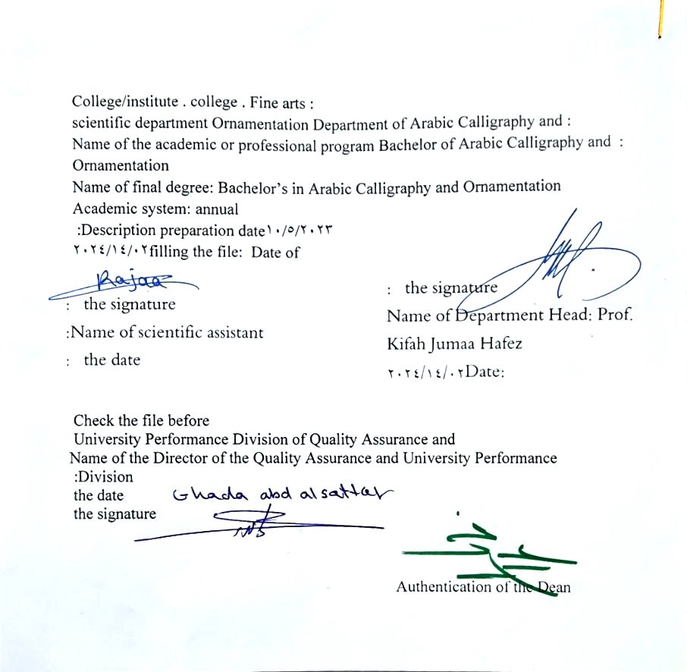

- See the program
The philosophy of the Department of Arabic Calligraphy and Ornamentation is based on achieving communication between originality and modernity, communication with the living heritage of Islamic art that has not exhausted its aesthetic and applied dimensions, and communication with cultural developments that will strengthen the creative thought of the arts of Arabic calligraphy and decoration, in addition to developing scientific capabilities by developing Students’ skills in this field are enriched, through the breadth of the educational and aesthetic experience and its openness to its counterparts in other universities in the world.

- Program message
Working to prepare and graduate leading scientific and leadership competencies in languages, sciences and literature, and to develop the balance of knowledge in the field of scientific research to serve the local, regional and international community, as well as training and refining the minds of students scientifically and cognitively, and emphasizing social and cultural values and responding to the requirements of the local market.

- Program Goals
1- Preparing academic and specialized calligraphers and decorators capable of implementing and presenting artistic projects in the arts of Arabic calligraphy and decoration, to meet the needs of the relevant state departments and the labor market, who hold a bachelor’s degree in the arts of Arabic calligraphy and decoration .
. 2- Preparing specialized researchers and artists with a high level of competence in the arts of Arabic calligraphy, decoration, and its aesthetics, for the purpose of contributing to the advancement of the artistic movement in Iraq and the Arab world, on objective foundations that rely on scientific research, experimentation, and committed art through graduate students .
3- Preparing the appropriate university-academic environment and climate for students to absorb the cognitive, skillful and emotional aspects of the arts of Arabic calligraphy and decoration, through curricular and extra-curricular activities and applied research studies that highlight the Arab heritage and embody the human meanings that the fine arts carry .
4- The department’s contribution to artistic activities and research projects at the level of the University of Baghdad and other Iraqi universities and at the level of relevant institutions, unions and artistic associations, in a way that serves the artistic process, scientific progress and the growing artistic awareness in Iraqi society .
5- Providing technical consultations in the arts of Arabic calligraphy and decoration to artistic institutions locally and internationally, in a way that serves and is consistent with the objectives of the department, relevant institutions and the development movement in our dear country .

- Program accreditation
nothing

- Other external influences
nothing

- Program structure
Program structure | Number of courses | Study unit | percentage | comments *
Enterprise requirements | 9 | 16 | 22.5% | Support decision
College requirements | 6 | 12 | 15% | Support decision
Department requirements | 26 | 52 | 65% | Basic course
summer training | nothing
Other
* Notes may include whether the course is core or elective.

- Program description
Year/level | Course or course code | Name of the course or course | Credit hours
fourth grade | G4-10 | The project | 5

- Expected learning outcomes of the programme
Knowledge
Cognitive goals | A1 - To be able to do the following at the end of the chapter  A2 - Knowing and understanding the principles, rules and foundations of building the project.  A3 - Possessing clarity in the cognitive aspect in order to reach a high degree of sober scientific awareness.  A4 - The student acquires practical skills that qualify him to implement the project.
Skills
B - Skills objectives of the program: | B1: The student acquires the intellectual cognitive skills required to be achieved.  B2 The student acquires the practical skills required to be accomplished.  B3: The student acquires personal skills at the level of the method required to be accomplished
Value
Developing students’ abilities to share ideas .
Students’ ability to create a structural map

- Teaching and learning strategies
Students learn how to complete an integrated project in terms of linear and decorative structures, as well as color treatments

- Evaluation methods
A - Project completion rates in the first and second semester
B- Distribution of evaluation grades for students’ graduation project material: 100%

- education institution
Faculty members
Scientific rank | Specialization |  | Special requirements/skills (if any) |  | Preparing the teaching staff
Scientific rank | general | private |  |  | angel | lecturer
Mr | 1 | 1 |  |  | 2
Assistant Professor | 1 | 5 |  |  | 6
Teacher | 2 | 1 |  |  | 3
assistant teacher |  | 5 |  |  | 3 | 2

Professional development
Orienting new faculty members
Briefly describes the process used to orient new, visiting, full-time, and part-time faculty at the institution and department levels.
Professional development for faculty members
Briefly describe the academic and professional development plan and arrangements for faculty members such as teaching and learning strategies, assessment of learning outcomes, professional development, etc.

- Acceptance standard
Special tests to uncover artistic and academic talents

- The most important sources of information about the program
Department's libraries
Personal libraries related to subject teaching
Library websites dedicated to calligraphy and decoration technicians

- Program development plan
- By working to find modern implementation techniques that are in harmony with current development.

Program skills chart
 |  |  |  | Learning outcomes required from the programme
Year / level | Course Code | Course Name | Essential or optional? | Knowledge |  |  |  | Skills |  |  |  | Value
 |  |  |  | A1 _ | A2 _ | A3 _ | A4 _ | B 1 | B2 _ | B3 _ | B4 _ | C1 _ | C 2 | C3 _ | C4 _
fourth grade | G4-10 | Simulation | Basic

- Please check the boxes corresponding to the individual learning outcomes from the program subject to evaluation

Course description form
- Course Name :
The project
- Course Code :
G4-3
- Semester / year
Annual
- Date this description was prepared :
02/14/2024
- Available forms of attendance :
My presence only
- Number of study hours (total)/number of units (total):
150 An hour annually . 5 An hour a week /5 units

- Name of the course administrator (if more than one name is mentioned)
Project Committee Email : aram.m@cofarts.uobaghdad.edu.iq

- Course objectives
C1 Observation, understanding, and interpretation of the course material.  C2 The ability to analyse, deduce, evaluate, and issue judgment.  C3: Deduction, measurement, and interpretation of the details of the course. |  |  |  |  |  | - ......  - ......  - ......
- Teaching and learning strategies
The strategy |  | - Education strategy, concept planning, cooperation through the use of foreign professors and acculturation among them  The department and college and twinning work with international colleges and universities  2- Brainstorming education strategy.  3- Education Strategy Notes Series
- Course structure
the week | hours |  | Required learning outcomes | Name of the unit or topic |  |  | Learning method | Evaluation method
1  2  3  4  5  6  7  8  9  10  11  12  13  14  15  vacation  16  17  18  19  19  20  21  22  23  24  25  26  27  28  29  30 | 5 hours |  | The student’s ability to know the topic studied each week | From the first to the third, present the diagrams  Proposals related to the project and discussed  Submitting the second half of the assigned work in color  From the third to the fifth, half of the assigned work is final  Ten: Progress from the twenty-seventh to the twenty-ninth Presenting and discussing theoretical research related to the project  From the fifteenth to the twenty-seventh: 30 evaluation of the final project |  |  | Through drills and exercises on the board and on cardboard, and through explanation, clarification, and experimentation | Weekly, monthly, daily, written exams, and the end-of-year exam .
- Course evaluation
Distribution is as follows : 100 degrees
- Learning and teaching resources
Creative calligraphic and decorative paintings
Main references (sources)
books and references in the fields of calligraphy and decoration
Electronic references, Internet sites

