
Ministry of Higher Education and Scientific Research
Scientific supervision and evaluation device
Department of Quality Assurance and Academic Accreditation
Accreditation Department

Academic program and course description guide. Academic program and course description guide

Academic program and course 2024

2024
the introduction:
The educational program is considered a coordinated and organized package of academic courses that includes procedures and experiences organized in the form of academic vocabulary, the main purpose of which is to build and refine the skills of graduates, making them qualified to meet the requirements of the labor market. It is reviewed and evaluated annually through internal or external audit procedures and programs such as the external examiner program.
The description of the academic program provides a brief summary of the main features of the program and its courses, indicating the skills that students are working to acquire based on the objectives of the academic program. The importance of this description is evident because it represents the cornerstone of obtaining program accreditation, and the teaching staff participates in writing it under the supervision of the scientific committees in the scientific departments.
This guide, in its second edition, includes a description of the academic program after updating the vocabulary and paragraphs of the previous guide in light of the latest developments in the educational system in Iraq, which included a description of the academic program in its traditional form (annual, quarterly), in addition to adopting the description of the academic program circulated according to the book of the Department of Studies 3/2906. On 5/3/2023 with regard to programs that adopt the Bologna Process as a basis for their work.
In this area, we can only emphasize the importance of writing descriptions of academic programs and courses to ensure the smooth conduct of the educational process.

Concepts and terminology:

Description of the academic program : The description of the academic program provides a brief summary of its vision, mission, and goals, including an accurate description of the targeted learning outcomes according to specific learning strategies.
Course Description : Provides a necessary summary of the most important characteristics of the course and the learning outcomes expected of the student to achieve, demonstrating whether he or she has made the most of the available learning opportunities. It is derived from the program description.
Program Vision: An ambitious picture for the future of the academic program to be a developed, inspiring, motivating, realistic and applicable program.
The program's mission: It briefly explains the goals and activities necessary to achieve them, and also defines the program's development paths and directions.
Program objectives: These are statements that describe what the academic program intends to achieve within a specific period of time and are measurable and observable.
Curriculum structure: All courses/study subjects included in the academic program according to the approved learning system (semester, annual, Bologna track), whether it is a requirement (ministry, university, college, or scientific department), along with the number of study units.
Learning outcomes: A consistent set of knowledge, skills, and values that the student has acquired after the successful completion of the academic program. The learning outcomes for each course must be determined in a way that achieves the program objectives.
Teaching and learning strategies : They are the strategies used by the faculty member to develop the student’s teaching and learning, and they are plans that are followed to reach the learning goals. That is, it describes all curricular and extracurricular activities to achieve the learning outcomes of the programme.

- 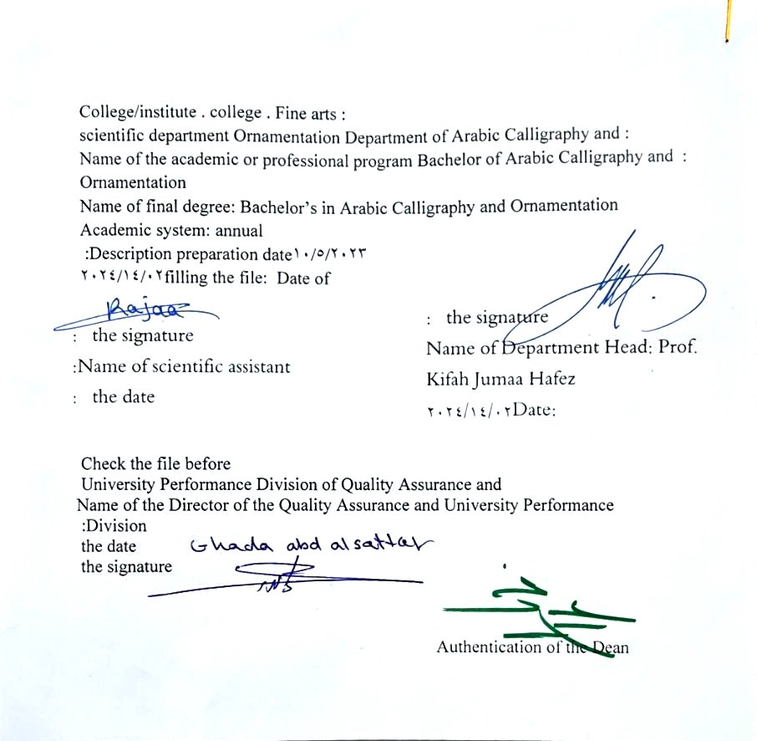 See the program
An ambitious picture for the future of the academic program to be an advanced, inspiring, motivating, realistic and applicable program.

- Program message
It briefly explains the objectives and activities necessary to achieve them, and also identifies the program’s development paths and directions.

- Program Goals
The program aims to provide a comprehensive description of the objectives of studying the Department of Arabic Calligraphy and Ornamentation and developing its curricula and performance applications within a strategic plan for development .

- Program accreditation
Does the program have program accreditation? From which side? Modular system

- Other external influences
Is there a sponsor for the program? Nothing

- Program structure
Program structure | Number of courses | Study unit | percentage | comments *
Enterprise requirements | 10 | 18 | 5 . 22
College requirements | 3 | 6 | 5 . 7
Department requirements | 33 | 56 | 70
summer training |  |  |  | nothing​
Other |  |  |  | nothing​
* Notes may include whether the course is core or elective.

- Program description
Year/level | Course or course code | Name of the course or course | Credit hours
 |  |  | theoretical | practical
A for a quarter | G 4-9 | English | 2 | 2

- Expected learning outcomes of the programme
Knowledge
Learning outcomes 1 | A - Cognitive objectives  A1 Definition in English and how to deal with it  2 Introducing the basic tools of the English language  3 concepts of the English language  4 Practice the foundations  5 Exercise and practical applications on the topic .
Skills
Learning outcomes 2 | Students’ ability to know the English language
Learning outcomes 3 | Statement of learning outcomes 3  1 - Enhancing students’ ability to pronounce English
Value
Learning outcomes 4 | Students’ ability to know and distinguish methods of teaching the English language
Learning outcomes 5 | Statement of learning outcomes 5  Learning through interpretation using means of illustration such as a smart board, piano, audio amplifier, data show , computer, or display screen.

- Teaching and learning strategies
Learning through interpretation using means of illustration such as a smart board, piano, audio amplifier, data show , computer, or display screen.

- Evaluation methods

Tests reveal the extent to which performance enhances the student's language knowledge

- education institution
Faculty members
Scientific rank | Specialization |  | Special requirements/skills (if any) |  | Preparing the teaching staff
Scientific rank | general | private |  |  | angel | lecturer
Mr | 5 | 5 |  |  | 5 | 0
Assistant Professor | 3 | 3 |  |  | 3 | 2
Teacher | 0 | 0 |  |  | 0 | 1
assistant teacher | 0 | 0 |  |  | 0 | 6

Professional development
Orienting new faculty members
Briefly describes the process used to orient new, visiting, full-time, and part-time faculty at the institution and department levels.
Professional development for faculty members
Briefly describe the academic and professional development plan and arrangements for faculty members such as teaching and learning strategies, assessment of learning outcomes, professional development, etc.

- Acceptance standard
Central acceptance

- The most important sources of information about the program
- Systematic books
- Scientific research
what

- Program development plan
- By working to update the vocabulary each year by 15%.

Program skills chart
 |  |  |  | Learning outcomes required from the programme
Year / level | Course Code | Course Name | Essential or optional? | Knowledge |  |  |  | Skills |  |  |  | Value
 |  |  |  | A1​ | A2​ | A3​ | A4​ | B 1 | B2​ | B3​ | B4​ | C1​ | C 2 | C3​ | C4​
The fourth stage | G4-9 | English | Basic | ✓ , | ✓ | ✓ | ✓ |  |  |  |  | ✓ | ✓ | ✓ | ✓

- Please check the boxes corresponding to the individual learning outcomes from the program subject to evaluation

Course description form
- Course Name : English
- Headquarters code 9 - G4
- Semester / year : 2023/2024
- Date this description was prepared
- Available attendance forms : weekly
- Number of study hours (total) / Number of units (total) : Number of hours 2 / Number of units ( 2 )
- Name of the course administrator (if more than one name is mentioned)
Name : Dr. Nabil Nasr Noman Email :

- Course objectives
 |  |  |  |  |  | ......  - ......  - ......
  Getting to know the English language and how to deal with it
        - Getting to know the basic tools of the English language
        - Familiarize students with the concepts of the English language
- Teaching and learning strategies
The strategy |  | Teaching method ( lecture - explanation - presentation of motor performance by the teacher, followed by a model from one of the students, then performance individually by the college ) increasing repetitions by the students .
- Course structure
the week | hours |  | Required learning outcomes | Name of the unit or topic | Learning method |  | Evaluation method
 | 2 |  | The student’s ability to know the topic studied this week | Unit 1  Grammar, vocabulary | giving a lecture |  | Theoretical test
 | 2 |  | The student’s ability to know the topic studied this week | Skill wory  EverythingEnglish sh | giving a lecture |  | Theoretical test
 | 2 |  | The student’s ability to know the topic studied this week | unit 2  ammar , vocabulary | giving a lecture |  | Theoretical test
 | 2 |  | The student’s ability to know the topic studied this week | Skill wory  EverythingEnglish | giving a lecture |  | Theoretical test
 | 2 |  | The student’s ability to know the topic studied this week | Unit 3  Skill wory  EverythingEnglish | Stay lectured |  | Theoretical test  And my work
 | 2 |  | The student’s ability to know the topic studied this week | Grammar  vocabulary | Giving a lecture and listening |  | Theoretical test  And my work
 | 2 |  | The students were able to pass The semester theoretical and practical test | The first exam for the first semester | Theoretical and practical exam |  | Theoretical test  And my work
 | 2 |  | The student’s ability to know the topic studied this week | unit 4  Skill wory  EverythingEnglish | Giving a lecture and listening |  | Theoretical test  And my work
 | 2 |  | The student’s ability to know the topic studied this week | Grammar vocabulary | giving a lecture  And listen |  | Theoretical test  And my work
 | 2 |  | The student’s ability to know the topic studied this week | Unit 5  Skill wory  EverythingEnglish | Giving a lecture and listening |  | Theoretical test  And my work
 | 2 |  | The students were able to pass The semester theoretical and practical test | Grammar  vocabulary | Giving a lecture and listening |  | Theoretical test  And my work
 | 2 |  | The student’s ability to know the topic studied this week | Unit 6  Skill wory  EverythingEnglish | Giving a lecture and listening |  | Theoretical test  And my work
 | 2 |  | The student’s ability to know the topic studied this week | Grammar vocabulary | giving a lecture  And listen |  | Theoretical test  And my work
 | 2 |  | The student’s ability to know the topic studied this week | Unit 7  Skill wory  EverythingEnglish | Giving a lecture and listening |  | Theoretical test  And my work
 | 2 |  | The students were able to pass The semester theoretical and practical test | The second exam for the first semester | Theoretical and practical exam |  | Theoretical test  And my work
 | 2 |  | The student’s ability to know the topic studied this week | A unit 8  Grammar vocabulary | Giving a lecture and listening |  | Theoretical test  And my work
 | 2 |  | The student’s ability to know the topic studied this week | Skill wory  EverythingEnglish | giving a lecture  And listen |  | Theoretical test  And my work
 | 2 |  | The student’s ability to know the topic studied this week | Unit 9  Grammar  vocabulary | Giving a lecture and listening |  | Theoretical test  And my work
 | 2 |  | The student’s ability to know the topic studied this week | Skill wory  EverythingEnglish | giving a lecture  And listen |  | Theoretical test  And my work
 | 2 |  | The student’s ability to know the topic studied this week | Unit 10  Grammar  vocabulary | Giving a lecture and listening |  | Theoretical test  And my work
 | 2 |  | The student’s ability to know the topic studied this week | Skill wory  EverythingEnglish | giving a lecture  And listen |  | Theoretical test  And my work
 | 2 |  | The students were able to pass The semester theoretical and practical test | first exam of the second semester | Theoretical and practical exam |  | Theoretical test  And my work
 | 2 |  | The student’s ability to know the topic studied this week | Unit 11  Grammar  vocabulary | Giving a lecture and listening |  | Theoretical test  And my work
 | 2 |  | The student’s ability to know the topic studied this week | a  Skill wory  EverythingEnglish | giving a lecture  And listen |  | Theoretical test  And my work
 | 2 |  | The student’s ability to know the topic studied this week | Unit 12  Grammar  vocabulary | Giving a lecture and listening |  | Theoretical test  And my work
 | 2 |  | The student’s ability to know the topic studied this week | Skill wory  EverythingEnglish | giving a lecture  And listen |  | Theoretical test  And my work
 | 2 |  | The student’s ability to know the topic studied this week | 13 unit Skill wory  EverythingEnglish | Giving a lecture and listening |  | Theoretical test  And my work
 | 2 |  | The student’s ability to know the topic studied this week | Grammar  vocabulary | Giving a lecture and listening |  | Theoretical test  And my work
 | 2 |  | The student’s ability to know the topic studied this week | Unit 14  Grammar,  Vocabulary Skill wory  EverythingEnglish | Giving a lecture and listening |  | Theoretical test  And my work
 | 2 |  | The students were able to pass The semester theoretical and practical test | The second exam for the second semester | Theoretical and practical exam |  | Theoretical test  And my work
- Course evaluation
Distribution of the score out of 100 according to the tasks assigned to the student, such as daily preparation, daily, monthly, and applied exams ... etc.
- Learning and teaching resources
Required textbooks (methodology, if any) |  |  |  | New Head way plus, Beginner
Main references (sources) |  |  |  | History of World Music - Theodore M. In me.  The Heritage of World Music - Kurt Sachs .  Music and Civilization - Hugo Lichtentritt .  Music in Western Civilization - Paul Henri Lange .  With world music - A. Dr.. Tariq Hassoun Farid.
Recommended supporting books and references (scientific journals, reports....) |  |  |  | Scientific research, theses, dissertations , and modern sources related to the subject studied
Electronic references, Internet sites |  |  |  | Websites of private libraries in the English language

