

Ministry of Higher Education and Scientific Research
Scientific supervision and evaluation device
Department of Quality Assurance and Academic Accreditation
Department Accreditation

guide
Description of the academic program and course
2024

The educational program is considered a coordinated and organized package of academic courses that includes procedures and experiences organized in the form of academic vocabulary, the main purpose of which is to build and refine the skills of graduates, making them qualified to meet the requirements of the labor market. It is reviewed and evaluated annually through internal or external audit procedures and programs such as the external examiner program.
the introduction
The description of the academic program provides a brief summary of the main features of the program and its courses, indicating the skills that students are working to acquire based on the objectives of the academic program. The importance of this description is evident because it represents the cornerstone of obtaining program accreditation, and the teaching staff participates in writing it under the supervision of the scientific committees in the scientific departments.
This guide, in its second edition, includes a description of the academic program after updating the vocabulary and paragraphs of the previous guide in light of the latest developments in the educational system in Iraq, which included a description of the academic program in its traditional form (annual, quarterly), in addition to adopting the description of the academic program circulated according to the book of the Department of Studies 3/2906. On 5/3/2023 with regard to programs that adopt the Bologna Process as a basis for their work.
In this area, we can only emphasize the importance of writing descriptions of academic programs and courses to ensure the smooth conduct of the educational process.

Concepts and terminology

Description of the academic program :
The academic program description provides a brief summary of its vision, mission, and objectives, including an accurate description of the targeted learning outcomes according to specific learning strategies.
Course description :
It provides a necessary summary of the most important characteristics of the course and the learning outcomes that the student is expected to achieve, demonstrating whether he has made the most of the learning opportunities available. It is derived from the program description.
Program vision:
An ambitious picture for the future of the academic program to be an advanced, inspiring, motivating, realistic and applicable program.
Program message:
It briefly explains the objectives and activities necessary to achieve them, and also identifies the program’s development paths and directions.
Program Goals:
They are statements that describe what the academic program intends to achieve within a specific period of time and are measurable and observable.
Curriculum structure:
All courses/study subjects included in the academic program according to the approved learning system (semester, annual, Bologna track), whether it is a requirement (ministry, university, college, or scientific department), along with the number of study units.
Learning Outcomes:
A compatible set of knowledge, skills, and values that the student has acquired after successfully completing the academic program. The learning outcomes for each course must be determined in a way that achieves the program objectives.
Teaching and learning strategies:
They are the strategies used by a faculty member to develop student teaching and learning, and they are plans that are followed to reach learning goals. That is, it describes all curricular and extracurricular activities to achieve the learning outcomes of the programme.
Academic program description form

University name: University of : Baghdad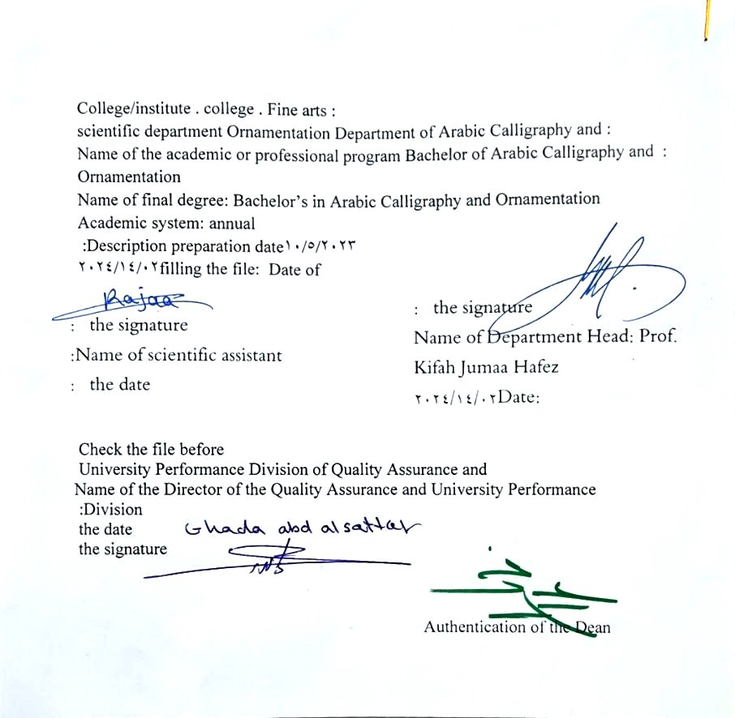

- See the program
The philosophy of the Department of Arabic Calligraphy and Ornamentation is based on achieving communication between originality and modernity, communication with the living heritage of Islamic art that has not exhausted its aesthetic and applied dimensions, and communication with cultural developments that will strengthen the creative thought of the arts of Arabic calligraphy and decoration, in addition to developing scientific capabilities by developing Students’ skills in this field are enriched , through the breadth of the educational and aesthetic experience and its openness to its counterparts in other universities in the world.

- Program message
Working to prepare and graduate leading scientific and leadership competencies in languages, sciences and literature, and to develop the balance of knowledge in the field of scientific research to serve the local, regional and international community, as well as training and refining the minds of students scientifically and cognitively, and emphasizing social and cultural values and responding to the requirements of the local market.

- Program Goals
A/ Preparing academic and specialized calligraphers and decorators who are able to implement and present artistic projects in the arts of Arabic calligraphy and decoration, to meet the needs of the relevant state departments and the labor market. They hold a bachelor’s degree in the arts of Arabic calligraphy and decoration .
B/ Preparing specialized researchers and artists with a high level of competence in the arts of Arabic calligraphy, decoration, and its aesthetics, for the purpose of contributing to the advancement of the artistic movement in Iraq and the Arab world, on objective foundations that rely on scientific research, experimentation, and committed art through graduate students .
C/ Preparing the appropriate university-academic environment and climate for students to absorb the cognitive, skillful and emotional aspects of the arts of Arabic calligraphy and decoration, through curricular and extra-curricular activities and applied research studies that highlight the Arab heritage and embody the human meanings that the fine arts carry .
D / The department’s contribution to artistic activities and research projects at the level of the University of Baghdad and other Iraqi universities and at the level of relevant institutions, unions and artistic associations, in a way that serves the artistic process, scientific progress and the growing artistic awareness in Iraqi society .
E/ Providing technical consultations in the arts of Arabic calligraphy and decoration to artistic institutions locally and internationally, in a way that serves and is consistent with the objectives of the department, relevant institutions and the development movement in our dear country .

- Program accreditation
nothing

- Other external influences
nothing

- Program structure
Program structure | Number of courses | Study unit | percentage | comments *
Enterprise requirements | 9 | 16 | 22.5% | Support decision
College requirements | 6 | 12 | 15% | Support decision
Department requirements | 26 | 52 | 65% | Basic course
summer training | nothing
Other
* Notes may include whether the course is core or elective.

- Program description
Year/level | Course or course code | Name of the course or course | Credit hours
third level |  | Decorative design | 4

- Expected learning outcomes of the programme
Knowledge
Identifying plant decorations with their floral and cup shapes and how they occupy the spaces within the decorative design of varying appearance and type of decorative employment, as well as introducing the technical principles followed in the structural organization of the decorative design.
Skills
Explaining the performance skills in the artistic directing process (establishing, building, and finishing), the type of techniques and materials used, and color treatments and their methods.
Value
Developing students’ abilities to share ideas
The ability to analyse, deduce, evaluate and obtain the desired results.

- Teaching and learning strategies
Paying attention to following the correct foundations and ways to enhance them in decorative formation, diversity of performance, skill and visual techniques accompanying the production of decorative design achieves the formal integrity of the work.

- Evaluation methods
A performance evaluation form according to a standard that depends on the nature of the academic subject through daily and monthly examinations.

- education institution
Faculty members
Scientific rank | Specialization |  | Special requirements/skills (if any) |  | Preparing the teaching staff
Scientific rank | general | private |  |  | angel | lecturer
Mr | 1 | 1 |  |  | 2
Assistant Professor | 1 | 5 |  |  | 6
Teacher | 2 | 1 |  |  | 3
assistant teacher |  | 5 |  |  | 3 | 2

Professional development
Orienting new faculty members
Professional development for faculty members

- Acceptance standard

- The most important sources of information about the program
A/ Books with a specific specialization related to Islamic architecture and its arts of a decorative nature.
B/ University theses and dissertations related to the applied laboratory subject.
C/ Realistic video and photo graphics of scenes with decorative designs can be used to explain the organizational methods, the formal diversity of the decorative items, and the mechanism of completion for the final work, such as monuments, places of worship, shrines, mosques, and so on.

- Program development plan
Studying the methods of establishment, artistic direction, techniques, raw materials, and method of processing decorative elements and units, and the possibility of employing them in the established ways, achieves the common duality between architectural construction and decorative decoration.

Program skills chart
 |  |  |  | Learning outcomes required from the programme
Year / level | Course Code | Course Name | Essential or optional? | Knowledge |  |  |  | Skills |  |  |  | Value
 |  |  |  | A1 _ | A2 _ | A3 _ | A4 _ | B 1 | B2 _ | B3 _ | B4 _ | C1 _ | C 2 | C3 _ | C4 _
2023-2024 |  | Decorative design | Basic

- Please check the boxes corresponding to the individual learning outcomes from the program subject to evaluation

Course description form
- Course Name :
Decorative design
- Course Code:
- Semester/Year: Annual
Annual
- Date this description was prepared
2/14/2024
- Available forms of attendance :
My presence only
- Number of study hours (total)/number of units (total):
90 hours annually. 3 hours per week

- Name of the course administrator (if more than one name is mentioned)
Name: A.M.D. Amin Abdel Zahra Yassin Al Nouri
Email: Ameen.Abd@cofarts.uobaghdad.edu.iq

- Course objectives
A/ Identifying decorations and methods of organizing them (origination and development)
B/ Identifying the tools for drawing vocabulary from the foundation stage until the necessary completion stage in employing shapes.
C/ Heritage concepts and scientific terminology for decorative elements and units.
D/ Initial exercise on drawing shapes and training on them.
E/Practice the comprehensive features of cadastral designs and enhance them with decorative works that fit the available space.
- Teaching and learning strategies
The strategy |  | A/ Models and samples.  B/ Imitating the realistic elements of decorative designs known in the architectural community and elsewhere.
- Course structure

Chapter one
the week | hours |  | Required learning outcomes | Name of the unit or topic |  | Learning method | Evaluation method
1 | 4 |  | Introduction to floral decorations  And its types | Decorative design |  | Models | Foundations and rules of decorative design
2 | 4 |  | Introduction to geometric decorations  And its types | Decorative design |  | Models | Foundations and rules of decorative design
3 | 4 |  | Introduction to the foundations and elements  Decorative design and its paragraphs | Decorative design |  | Models | Foundations and rules of decorative design
4 | 4 |  | Practical application  1. Adopting the principle of double repetition  In cadastral division and unit preparation  One | Decorative design |  | Models | Foundations and rules of decorative design
5 | 4 |  | Practical assignment of the previous application and obtaining the overall form. | Decorative design |  | Models | Foundations and rules of decorative design
6 | 4 |  | 2. Adopting the principle of quadruple repetition  In cadastral division and unit preparation  One. | Decorative design |  | Models | Foundations and rules of decorative design
7 | 4 |  | Practical assignment of the previous application  And obtaining the overall shape | Decorative design |  | Models | Foundations and rules of decorative design
8 | 4 |  | 3. Adopting the principle of radial repetition  In cadastral division and unit preparation  One. | Decorative design |  | Models | Foundations and rules of decorative design
9 | 4 |  | Practical assignment of the previous application  And obtaining the overall shape | Decorative design |  | Models | Foundations and rules of decorative design
10 | 4 |  | 4. Adopting the principle of circular repetition  In cadastral division and unit preparation  One. | Decorative design |  | Models | Foundations and rules of decorative design
11 | 4 |  | Practical assignment of the previous application  And obtaining the overall shape | Decorative design |  | Models | Foundations and rules of decorative design
12 | 4 |  | Adopting the principle of tape repetition  In cadastral division and unit preparation  One. | Decorative design |  | Models | Foundations and rules of decorative design
13 | 4 |  | Practical assignment of the previous application  And obtaining the overall shape | Decorative design |  | Models | Foundations and rules of decorative design
14 | 4 |  | General review | Decorative design |  | Models | Foundations and rules of decorative design
15 | 4 |  | First semester exam | Decorative design |  | Models | Foundations and rules of decorative design
Chapter II

the week | hours | Required learning outcomes | Name of the unit or topic | Learning method | Evaluation method
16 | 4 | Introducing the various decorative designs employed at the level of designs for the Qur’ans and their covers, calligraphic paintings, and wall decorations in Islamic buildings. | Decorative design | Models | Foundations and rules of decorative design
17 | 4 | Reviewing a group of decorative formations in calligraphic paintings, the Qur’an, carpets, and architecture, and explaining their design features | Decorative design | Models | Foundations and rules of decorative design
18 | 4 | Practical application: Data from the first chapter and their embodiment in simulating one of the decorative designs of (Qurans - covers of the Holy Quran - carpets - ... and others) | Decorative design | Models | Foundations and rules of decorative design
19 | 4 | Choose one of these technical fields and prepare the foundational draft for cadastral measurement and internal organization of the chosen project. | Decorative design | Models | Foundations and rules of decorative design
20 | 4 | The actual preparation of the application, stating the details of the work, and approving its schedule  Not complete and evaluated. | Decorative design | Models | Foundations and rules of decorative design
21 | 4 | Follow up on the first part of the application and identify the negative and positive aspects and correct them. | Decorative design | Models | Foundations and rules of decorative design
22 | 4 | Follow up on the second part of the application and identify the negative and positive aspects and correct them. | Decorative design | Models | Foundations and rules of decorative design
23 | 4 | Follow up on the third part of the application and identify the negative and positive aspects and correct them. | Decorative design | Models | Foundations and rules of decorative design
24 | 4 | Follow up on the fourth part of the application and identify the negative and positive aspects and correct them. | Decorative design | Models | Foundations and rules of decorative design
25 | 4 | Follow up on the fifth part of the application and identify the negative and positive aspects and correct them. | Decorative design | Models | Foundations and rules of decorative design
26 | 4 | General Review | Decorative design | Models | Foundations and rules of decorative design
27 | 4 | The stage of comprehensive application of all general parts and their final processing. | Decorative design | Models | Foundations and rules of decorative design
28 | 4 | Follow the application | Decorative design | Models | Foundations and rules of decorative design
29 | 4 | Follow the application | Decorative design | Models | Foundations and rules of decorative design
30 | 4 | Final evaluation of the application | Decorative design | Models | Foundations and rules of decorative design
- Course evaluation
Distribution as follows:
A/50 marks for monthly and daily exams for the first semester .
B / 50 marks for monthly and daily exams for the second semester.
C/ The two grades are combined as a final evaluation of the course.
- Learning and teaching resources
Required textbooks (methodology, if any) | A/ Books with a specific specialization related to Islamic architecture and its arts of a decorative nature.  B/ University theses and dissertations related to the applied laboratory subject.  C/ Realistic video and photo graphics of scenes with decorative designs can be used to explain organizational methods, the formal diversity of decorative items, and the mechanism of completion of the final work, such as monuments, places of worship, shrines, mosques, and so on.
Main references (sources) | A/ Books with a specific specialization related to Islamic architecture and its arts of a decorative nature.  B/ University theses and dissertations related to the applied laboratory subject.  C/ Realistic video and photo graphics of scenes with decorative designs can be used to explain organizational methods, the formal diversity of decorative items, and the mechanism of completion of the final work, such as monuments, places of worship, shrines, mosques, and so on.
Recommended supporting books and references (scientific journals, reports....)
Electronic references, Internet sites

