
Ministry of Higher Education and Scientific Research
Scientific supervision and evaluation device
Department of Quality Assurance and Academic Accreditation
Department.Accreditation

دليل وصف البرنامج الأكاديمي والمقردليل وصف البرنامج الأكاديمي والمقرر الدراسي

Academic program and course description guide

2024
The introduction:
The educational program is considered a coordinated and organized package of academic courses that includes procedures and experiences organized in the form of academic vocabulary, the main purpose of which is to build and refine the skills of graduates, making them qualified to meet the requirements of the labor market. It is reviewed and evaluated annually through internal or external audit procedures and programs such as the external examiner program.
The description of the academic program provides a brief summary of the main features of the program and its courses, indicating the skills that students are working to acquire based on the objectives of the academic program. The importance of this description is evident because it represents the cornerstone of obtaining program accreditation, and the teaching staff participates in writing it under the supervision of the scientific committees in the scientific departments.
This guide, in its second edition, includes a description of the academic program after updating the vocabulary and paragraphs of the previous guide in light of the latest developments in the educational system in Iraq, which included a description of the academic program in its traditional form (annual, quarterly), in addition to adopting the description of the academic program circulated according to the book of the Department of Studies, 3/2906. On 5/3/2023 with regard to programs that adopt the Bologna Process as a basis for their work.
In this area, we can only emphasize the importance of writing descriptions of academic programs and courses to ensure the smooth conduct of the educational process.

Concepts and terminology

Description of the academic program: The description of the academic program provides a brief summary of its vision, mission, and objectives, including an accurate description of the targeted learning outcomes according to specific learning strategies
Course Description: Provides a necessary summary of the most important characteristics of the course and the learning outcomes that the student is expected to achieve, demonstrating whether he or she has made the most of the available learning opportunities. It is derived from the program description
Program Vision: An ambitious picture for the future of the academic program to be a developed, inspiring, motivating, realistic and applicable programmeThe program's mission: It briefly explains the goals and activities necessary to achieve them, and also defines the program's development paths and directions.
Program objectives: These are statements that describe what the academic program intends to achieve within a specific period of time and are measurable and observable.
Curriculum structure: All courses/study subjects included in the academic program according to the approved learning system (semester, annual, Bologna track), whether it is a requirement (ministry, university, college, or scientific department), along with the number of study units.
Learning outcomes: A consistent set of knowledge, skills, and values that the student has acquired after the successful completion of the academic program. The learning outcomes for each course must be determined in a way that achieves the program objectives.
Teaching and learning strategies: They are the strategies used by the faculty member to develop the student’s teaching and learning, and they are plans that are followed to reach the learning goals. That is, it describes all curricular and extracurricular activities to achieve the learning outcomes of the programme.

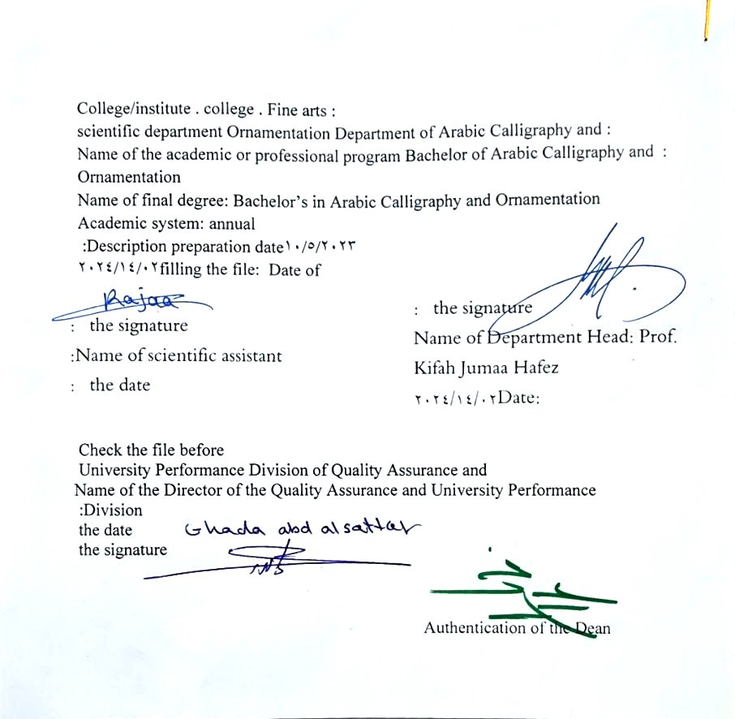
1. Program vision
The philosophy of the Department of Arabic Calligraphy and Ornamentation is based on achieving communication between originality and modernity, communication with the living heritage of Islamic art that has not exhausted its aesthetic and applied dimensions, and communication with cultural developments that will strengthen the creative thought of the arts of Arabic calligraphy and decoration, in addition to developing scientific capabilities by developing skills. Students in this rich field, through the breadth of the educational and aesthetic experience and its openness to its counterparts in other universities in the world..

2. Program message
Working to prepare and graduate leading scientific and leadership competencies in languages, sciences and literature, and to develop the balance of knowledge in the field of scientific research to serve the local, regional and international community, as well as training and refining the minds of students scientifically and cognitively, and emphasizing social and cultural values and responding to the requirements of the local market.

3. Program Goals
1Preparing academic and specialized calligraphers and decorators capable of implementing and presenting artistic projects in the arts of Arabic calligraphy and decoration, to meet the needs of the relevant state departments and the labor market, who hold a bachelor’s degree in the arts of Arabic calligraphy and decoration.
. 2Preparing specialized researchers and artists with a high level of competence in the arts of Arabic calligraphy, decoration, and its aesthetics, for the purpose of contributing to the advancement of the artistic movement in Iraq and the Arab world, on objective foundations that rely on scientific research, experimentation, and committed art through graduate students.
3Preparing the appropriate university-academic environment and climate for students to absorb the cognitive, skillful and emotional aspects of the arts of Arabic calligraphy and decoration, through curricular and extra-curricular activities and applied research studies that highlight the Arab heritage and embody the human meanings that the fine arts carry.
4The department’s contribution to artistic activities and research projects at the level of the University of Baghdad and other Iraqi universities and at the level of relevant institutions, unions and artistic associations, in a way that serves the artistic process, scientific progress and the growing artistic awareness in Iraqi society.
5Providing technical consultations in the arts of Arabic calligraphy and decoration to artistic institutions locally and internationally, in a way that serves and is consistent with the objectives of the department, relevant institutions and the development movement in our dear country.

4.Program accreditation
Nothing

5. Other external influences
Nothing

Program structure 6.
Program structure | Number of courses | Study unit | percentage | comments *
Enterprise requirements | 9 | 16 | 22.5% | Support decision
College requirements | 6 | 12 | 15% | Support decision
Department requirements | 26 | 52 | 65% | Basic course
summer training | nothing
Other
* Notes may include whether the course is core or elective.
Program description
Year/level | Course or course code | Name of the course or course | Credit hours
the second | G2-8 | Artistic psychology | theoretical | theoretical  practical
 |  |  | 2

1. Expected learning outcomes of the program
Knowledge
Outputs 1 | Cognitive goals  Introducing artistic psychology and its concept  The goals, tasks and fields of psychology  philosophical theories that explained artistic psychology and creativity
Skills
Outputs 2 | The student acquires the cognitive and intellectual skills required to be achieved
Outputs 3 | Developing the student’s scientific skills to be achieved
Value
Outputs 4 | The student’s ability to know the factors behind creative behavior and their relationship to personal temperamental traits
Outputs 5 | Developing sensory and psychological skills through interpreting the artist’s self-development

Teaching and learning strategies
- Explaining the scientific material by using means of illustration such as data, computer, and display screen, as well as giving examples of artists and theories of creativity.. -

Evaluation methods
Tests reveal the student’s technical and skill performance through pillars within the prescribed curriculum

The teaching staff
Faculty members
Scientific rank | Specialization |  | Special requirements/skills (if any) |  | Preparing the faculty
Scientific rank | general | خاص |  |  | Teaching staff | lecturer
PROF | 1 | 1 |  | 2 | 2
Assistant Professor | 1 | 5 |  | 6 | 6
Teacher | 2 | 1 |  | 3 | 3
assistant teacher |  | 3 |  | 3 | 3 | 2

Professional development
Orienting new faculty members
Briefly describes the process used to orient new and visiting faculty at the institution and department levels
Professional development for faculty members
It briefly describes the academic and professional development plan and practices for faculty members, such as teaching and learning strategies, skill and evaluation, professional development...

Acceptance standard
Special tests to reveal the artistic talent and psychological factor of the artist ))

The most important sources of information about the program
Books and references within the curriculum and research related to the specialty.

Program development plan
Seeking the assistance of professors and scientific research specialized in this field to shed light on the perceptions, processes and stages of creativity of the artist in various fields.

Program skills chart
 |  |  |  | مخرجات التعلم المطلوبة من البرنامج
Year/level | Course Code | Course Name | Essential or optional | Knowledge |  |  |  | The skills |  |  |  | Value
 |  |  |  | أ1 | أ2 | أ3 | أ4 | ب1 | ب2 | ب3 | ب4 | ج1 | ج2 | ج3 | ج4
2023-2024 |  | Artistic psychology | Essential

- Please check the boxes corresponding to the individual learning outcomes from the program subject to evaluation

نموذج وصف المقرر
1. Course name: Artistic psychology
2. Course code: G2-8
. Semester/Year: 2023-2024
Annual
2. Date this description was prepared: 02/14/2024
3. Available attendance forms:
My attendance is mandatory
4. Number of study hours (total)/number of units (total):
2 hours a week 2
5. Name of the course administrator (if more than one name is mentioned)
Name: Prof. Muna Kadhem Abed
6. Course objectives
 |  |  |  |  |  | Introducing students to the most important factors, goals, stages of creativity, and philosophical theories for developing the artist’s self
7- Teaching method
 |  | (lecture - explanation - implementation in front of the students of part of the miniature by the teacher, then making models by the students, then performing the individual work by the student, then implementing the other parts with colors.
8. Course structure
الأسبوع | الساعات |  | Required learning outcomes | Name of the unit or topic |  |  | Learning method | Evaluation method
1 | 2 |  | The student’s ability to understand and know the topic studied this week | Introduction to psychology and its concept |  |  | giving a lecture | Theoretical test
2 | 2 |  | The student’s ability to understand and know the topic studied this week | General psychology (its topics and goals |  |  | giving a lecture | Theoretical test
3 | 2 |  | The student’s ability to understand and know the topic studied this week | The tasks and fields of psychology |  |  | giving a lecture | Theoretical test
4 | 2 |  | The student’s ability to understand and know the topic studied this week | Meaning of behavior |  |  | giving a lecture | Theoretical test
5 | 2 |  | The student’s ability to understand and know the topic studied this week | The meaning of art and the artist and who is the creative artist |  |  | Giving a lecture and doing the cover parts | Theoretical and practical test
6 | 2 |  | The student’s ability to understand and know the topic studied this week | The meaning that is based on the relationship between the artist and the environment in which he lives |  |  | giving a lecture | Theoretical test
7 | 2 |  | The student’s ability to understand and know the topic studied this week | Topics of artistic psychology, the concept of artistic creative behavior |  |  | Theoretical exam | Theoretical test
8 | 2 |  | The student’s ability to understand and know the topic studied this week | First semester test |  |  | giving a lecture | Theoretical test
9 | 2 |  | The student’s ability to understand and know the topic studied this week | Analysis of creative behavior (choosing a model for an artist) |  |  | giving a lecture | Theoretical test
10 | 2 |  | The student’s ability to understand and know the topic studied this week | Creative thinking directed at solving problems |  |  | giving a lecture | Theoretical test
11 | 2 |  | The student’s ability to understand and know the topic studied this week | Creative factors behind creative behavior |  |  | giving a lecture | Theoretical test
12 | 2 |  | The student’s ability to understand and know the topic studied this week | Mental factors of creativity (fluency, flexibility, originality, sensitivity to problems) |  |  | giving a lecture | Theoretical and practical test
13 | 2 |  | The student’s ability to understand and know the topic studied this week | Classification of creative factors |  |  | giving a lecture | Theoretical test
14 | 2 |  | The student’s ability to understand and know the topic studied this week | Levels of artistic creativity |  |  | giving a lecture | Theoretical test
15 | 2 |  | The student’s ability to understand and know the topic studied this week | The components of the creative process, its stages, and how to produce the artistic work |  |  | End of semester exam | Theoretical test
Rest |  |  |  | Initial semester exam at the end of the first semester
16 | 2 |  | The student’s ability to understand and know the topic studied this week |  |  |  | giving a lecture | Theoretical test
17 | 2 |  | The student’s ability to understand and know the topic studied this week | Elements of the creative process |  |  | giving a lecture | Theoretical test
18 | 2 |  | The student’s ability to understand and know the topic studied this week | Stages of the creative process (preparation, fermentation, illumination, verification) |  |  | giving a lecture | Theoretical test
19 | 2 |  | The student’s ability to understand and know the topic studied this week | How to produce an artwork (an application for an artwork) |  |  | giving a lecture | Theoretical test
20 | 2 |  | The student’s ability to understand and know the topic studied this week | Theories and opinions that explain the creativity process |  |  | giving a lecture | Theoretical test
21 | 2 |  | The student’s ability to understand and know the topic studied this week | Inspiration Intuition |  |  | giving a lecture | Theoretical test
22 | 2 |  | The student’s ability to understand and know the topic studied this week | Interpreting the theory of modern psychoanalysis in explaining creativity |  |  | Semester exam | Theoretical test
23 | 2 |  | The student’s ability to understand and know the topic studied this week | Freud and Jung's perspective on the psychoanalysis of creativity |  |  | giving a lecture | Theoretical test
24 | 2 |  | The student’s ability to understand and know the topic studied this week | Semester test for the second semester |  |  | giving a lecture | Theoretical test
25 | 2 |  | The student’s ability to understand and know the topic studied this week | Interpreting the creative process in light of Gestalt theory (applications in the field of Arabic calligraphy specialization) |  |  | giving a lecture | Theoretical test
26 | 2 |  | The student’s ability to understand and know the topic studied this week | How artistic appreciation occurs |  |  | giving a lecture | Theoretical test
27 | 2 |  | The student’s ability to understand and know the topic studied this week | The artistic subject and its aesthetic elements |  |  | giving a lecture | Theoretical test
28 | 2 |  | The student’s ability to understand and know the topic studied this week | Aesthetic education, its concept and importance |  |  | giving a lecture | Theoretical test
29 | 2 |  | The student’s ability to understand and know the topic studied this week | Developing preparations for artistic creativity |  |  | giving a lecture | Theoretical test
30 | 2 |  | The student’s ability to understand and know the topic studied this week | The psychological basis of artistic taste |  |  | a test | Theoretical test
9. Course evaluation
Distribution is as follows: 25 marks for monthly and daily exams for the first semester. 25 marks for monthly and daily exams for the second semester. 50 marks for final exams
Learning and teaching resources
Required textbooks (methodology, if any) |  |  |  |  | English Victorian and Modern Poetry

Main references (sources) | Artistic Psychology, Abu Talib Saeed, 1990
Recommended supporting books and references (scientific journals, reports....) | Creativity in art and science, Dr. Hassan Ahmed, the world of knowledge
Electronic references, Internet sites | Art is Experience, John Dewey, edited by Zakaria Ibrahim, 1963

1

