

Ministry of Higher Education and Scientific Research
Scientific supervision and evaluation device
Department of Quality Assurance and Academic Accreditation
Department Accreditation

guide
Description of the academic program and course
2024

The educational program is considered a coordinated and organized package of academic courses that includes procedures and experiences organized in the form of academic vocabulary, the main purpose of which is to build and refine the skills of graduates, making them qualified to meet the requirements of the labor market. It is reviewed and evaluated annually through internal or external audit procedures and programs such as the external examiner program.
the introduction
The description of the academic program provides a brief summary of the main features of the program and its courses, indicating the skills that students are working to acquire based on the objectives of the academic program. The importance of this description is evident because it represents the cornerstone of obtaining program accreditation, and the teaching staff participates in writing it under the supervision of the scientific committees in the scientific departments.
This guide, in its second edition, includes a description of the academic program after updating the vocabulary and paragraphs of the previous guide in light of the latest developments in the educational system in Iraq, which included a description of the academic program in its traditional form (annual, quarterly), in addition to adopting the description of the academic program circulated according to the book of the Department of Studies 3/2906. On 5/3/2023 with regard to programs that adopt the Bologna Process as a basis for their work.
In this area, we can only emphasize the importance of writing descriptions of academic programs and courses to ensure the smooth conduct of the educational process.

Concepts and terminology

Description of the academic program :
The academic program description provides a brief summary of its vision, mission, and objectives, including an accurate description of the targeted learning outcomes according to specific learning strategies.
Course description :
It provides a necessary summary of the most important characteristics of the course and the learning outcomes that the student is expected to achieve, demonstrating whether he has made the most of the learning opportunities available. It is derived from the program description.
Program vision:
An ambitious picture for the future of the academic program to be an advanced, inspiring, motivating, realistic and applicable program.
Program message:
It briefly explains the objectives and activities necessary to achieve them, and also identifies the program’s development paths and directions.
Program Goals:
They are statements that describe what the academic program intends to achieve within a specific period of time and are measurable and observable.
Curriculum structure:
All courses/study subjects included in the academic program according to the approved learning system (semester, annual, Bologna track), whether it is a requirement (ministry, university, college, or scientific department), along with the number of study units.
Learning Outcomes:
A compatible set of knowledge, skills, and values that the student has acquired after successfully completing the academic program. The learning outcomes for each course must be determined in a way that achieves the program objectives.
Teaching and learning strategies:
They are the strategies used by a faculty member to develop student teaching and learning, and they are plans that are followed to reach learning goals. That is, it describes all curricular and extracurricular activities to achieve the learning outcomes of the programme.
Academic program description form

University name: University of : Baghdad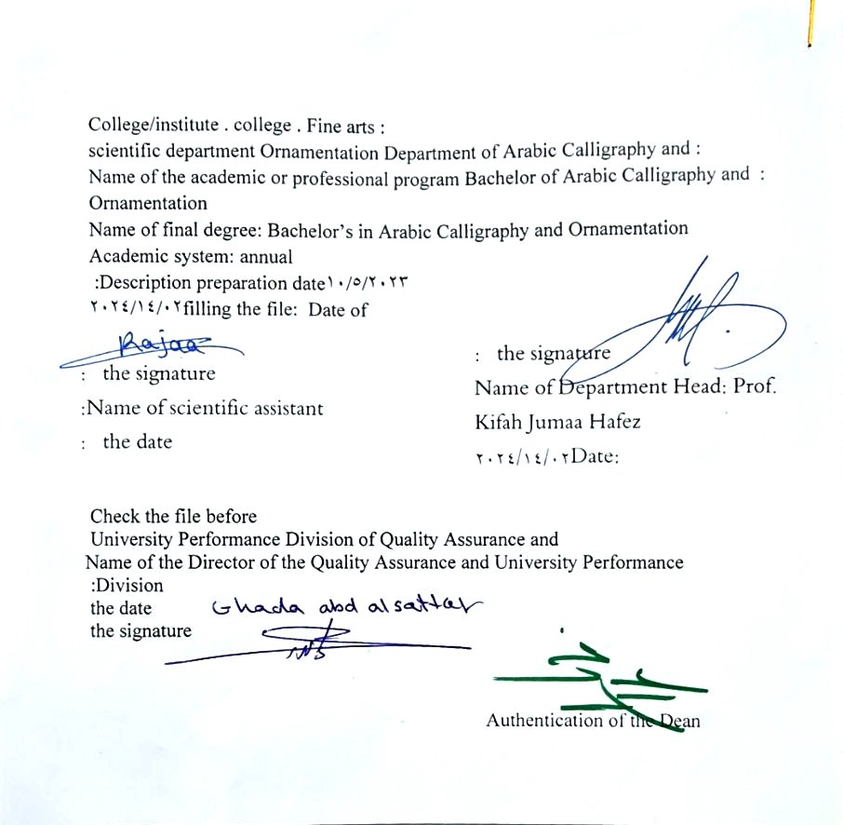

- See the program
The philosophy of the Department of Arabic Calligraphy and Ornamentation is based on achieving communication between originality and modernity, communication with the living heritage of Islamic art that has not exhausted its aesthetic and applied dimensions, and communication with cultural developments that will strengthen the creative thought of the arts of Arabic calligraphy and decoration, in addition to developing scientific capabilities by developing Students’ skills in this field are enriched , through the breadth of the educational and aesthetic experience and its openness to its counterparts in other universities in the world.

- Program message
Working to prepare and graduate leading scientific and leadership competencies in languages, sciences and literature, and to develop the balance of knowledge in the field of scientific research to serve the local, regional and international community, as well as training and refining the minds of students scientifically and cognitively, and emphasizing social and cultural values and responding to the requirements of the local market.

- Program Goals
A/ Preparing academic and specialized calligraphers and decorators who are able to implement and present artistic projects in the arts of Arabic calligraphy and decoration, to meet the needs of the relevant state departments and the labor market. They hold a bachelor’s degree in the arts of Arabic calligraphy and decoration .
B/ Preparing specialized researchers and artists with a high level of competence in the arts of Arabic calligraphy, decoration, and its aesthetics, for the purpose of contributing to the advancement of the artistic movement in Iraq and the Arab world, on objective foundations that rely on scientific research, experimentation, and committed art through graduate students .
C/ Preparing the appropriate university-academic environment and climate for students to absorb the cognitive, skillful and emotional aspects of the arts of Arabic calligraphy and decoration, through curricular and extra-curricular activities and applied research studies that highlight the Arab heritage and embody the human meanings that the fine arts carry .
D / The department’s contribution to artistic activities and research projects at the level of the University of Baghdad and other Iraqi universities and at the level of relevant institutions, unions and artistic associations, in a way that serves the artistic process, scientific progress and the growing artistic awareness in Iraqi society .
E/ Providing technical consultations in the arts of Arabic calligraphy and decoration to artistic institutions locally and internationally, in a way that serves and is consistent with the objectives of the department, relevant institutions and the development movement in our dear country .

- Program accreditation
nothing

- Other external influences
nothing

- Program structure
Program structure | Number of courses | Study unit | percentage | comments *
Enterprise requirements
College requirements
Department requirements
summer training
Other
* Notes may include whether the course is core or elective.

- Program description
Year/level | Course or course code | Name of the course or course | Credit hours
The fourth stage |  | Architectural leadership | 4

- Expected learning outcomes of the programme
Knowledge
Exploring the technical foundations of the pioneering elements in Islamic architecture as part of the cultural and historical heritage, giving importance to understanding and studying these topics, and acquiring skills capable of performing the applied aspect of artistic achievements.
Skills
Identify the performative principles in drawing and explain the methods of extracting the mathematical elements (domes - Minarets - Seating - geometric decorations - square decorations) in a scientific manner and assigning terminological names to them
Value
Developing students’ abilities to share ideas
The ability to analyse, deduce, evaluate and obtain the desired results.

- Teaching and learning strategies
Relying on sound principles in explaining shapes and mathematical elements, methods of their virtual extraction, and the possibility of developing them in light of the available data at the level of the targeted place, the available space, and the chosen style, as well as adopting special electronic programs in architectural drawing as a skill enhancement within extracurricular assignments and participations.

- Evaluation methods
A performance evaluation form according to a standard that depends on the nature of the academic subject through daily and monthly examinations.

- education institution
Faculty members
Scientific rank | Specialization |  | Special requirements/skills (if any) |  | Preparing the teaching staff
Scientific rank | general | private |  |  | angel | lecturer
Mr
Assistant Professor
Teacher
assistant teacher

Professional development
Orienting new faculty members
Professional development for faculty members

- Acceptance standard

- The most important sources of information about the program
A/ Books with a specific specialization related to Islamic architecture and its arts.
B/ University theses and dissertations related to the applied laboratory subject.
C/ Realistic videography and photo-graphy of scenes that employ visual elements such as monuments, places of worship, shrines, mosques, etc.

- Program development plan
Studying the methods of establishing and artistic production of the artistic elements and the possibility of employing them in the established ways achieves the common duality between architectural construction and decorative decoration.

Program skills chart
 |  |  |  | Learning outcomes required from the programme
Year / level | Course Code | Course Name | Essential or optional? | Knowledge |  |  |  | Skills |  |  |  | Value
 |  |  |  | A1 _ | A2 _ | A3 _ | A4 _ | B 1 | B2 _ | B3 _ | B4 _ | C1 _ | C 2 | C3 _ | C4 _
2023-2024 |  | Architectural leadership | Basic

- lease check the boxes corresponding to the individual learning outcomes from the program subject to evaluation

Course description form
- Course Name :
Architectural leadership
- Course Code:

- Semester/Year: Annual
Annual
- Date this description was prepared
2/14/2024
- Available forms of attendance :
My presence only
- Number of study hours (total)/number of units (total):
- Name of the course administrator (if more than one name is mentioned)
Name : A.M.D. Amin Abdel Zahra Yassin Al Nouri
Email : Ameen.Abd@cofarts.uobaghdad.edu.iq

- Course objectives
A/ Identifying architectural elements ( origin and development)
B/ Identifying the special engineering drawing tools needed to draw architectural shapes .
C/ Traditional concepts and scientific terminology of the mathematical elements .
D/ Initial exercise on drawing shapes and training on them.
E/Exercise on the comprehensive drawings of the architectural element with all its details, such as 0 entrances - Minarets – Domes)
- Teaching and learning strategies
The strategy |  | A/ Models and samples.  B/ Simulating the realistic elements of (contracts ) Minarets - Domes, known in the architectural community.
- Course structure

Chapter one
the week | hours |  | Required learning outcomes | Name of the unit or topic |  | Learning method | Evaluation method
1 | 4 |  | An introductory overview of the course | Architectural leadership |  | Models | Technical foundations
2 | 4 |  | Definition of the basis of elements  Ammaria | Architectural leadership |  | Models | Technical foundations
3 | 4 |  | Identify performance methods  Used in drawing shapes  And its types. | Architectural leadership |  | Models | Technical foundations
4 | 4 |  | Pre-workouts of the elements  Engineering and methods of use  Engineering tools. | Architectural leadership |  | Models | Technical foundations
5 | 4 |  | Exercises on the Riyazi element  (Contract )  - The arch is semi-arched  What is known as ( Al-Mutanf ) | Architectural leadership |  | Models | Technical foundations
6 | 4 |  | 2 - The pointed knot has two centres  In several ways. | Architectural leadership |  | Models | Technical foundations
7 | 4 |  | 3 - The pointed knot of three  centers | Architectural leadership |  | Models | Technical foundations
8 | 4 |  | 4 - The pointed knot of four  centers | Architectural leadership |  | Models | Technical foundations
9 | 4 |  | 5 - The pointed, obtuse necklace  Four centers | Architectural leadership |  | Models | Technical foundations
10 | 4 |  | 6 - The pointed, obtuse necklace  Five centers | Architectural leadership |  | Models | Technical foundations
11 | 4 |  | 7 – Trilobular ganglion  And the pentagram | Architectural leadership |  | Models | Technical foundations
12 | 4 |  | 8 - A contract that is similar to contracts  Previous . | Architectural leadership |  | Models | Technical foundations
13 | 4 |  | 9 - A contract similar to a contract  Previous | Architectural leadership |  | Models | Technical foundations
14 | 4 |  | General Review | Architectural leadership |  | Models | Technical foundations
15 | 4 |  | First semester exam | Architectural leadership |  | Models | Technical foundations
Chapter II

the week | hours | Required learning outcomes | Name of the unit or topic | Learning method | Evaluation method
16 | 4 | Introduction to the elements  Ornamental (botanical - geometric) | Architectural leadership | Models | Technical foundations
17 | 4 | Introduction to geometric decoration  And the types of employees in architecture  Islamic. | Architectural leadership | Models | Technical foundations
18 | 4 | Practice on one of the models for decorations  Engineering (star) | Architectural leadership | Models | Technical foundations
19 | 4 | Class assignment about preparation  Integrated model and iteration method  Previous geometric shape. | Architectural leadership | Models | Technical foundations
10 | 4 | Practicing another form of geometric decoration (starry) | Architectural leadership | Models | Technical foundations
11 | 4 | Class assignment about preparation  Integrated model and iteration method  Previous geometric shape. | Architectural leadership | Models | Technical foundations
12 | 4 | 1/ Exercise on the decorative element  For square motifs and preparing a model for it | Architectural leadership | Models | Technical foundations
13 | 4 | 2 / Exercise on the decorative element  For square motifs and preparing a model for it | Architectural leadership | Models | Technical foundations
14 | 4 | Exercise on the rhizome  Ammari (balconies) and choosing models  Of which . | Architectural leadership | Models | Technical foundations
15 | 4 | Practical application in recruitment  Elements within one of the architectural edifices  Islamic (face - minaret ) | Architectural leadership | Models | Technical foundations
16 | 4 | Follow the application and choose the model  And evaluate it. | Architectural leadership | Models | Technical foundations
17 | 4 | Follow the application and choose the model  And evaluate it. | Architectural leadership | Models | Technical foundations
18 | 4 | Follow the application and choose the model  And evaluate it. | Architectural leadership | Models | Technical foundations
19 | 4 | General review about the application | Architectural leadership | Models | Technical foundations
30 | 4 | The final completion of practical application | Architectural leadership | Models | Technical foundations
- Course evaluation
Distribution as follows:
A/50 marks for monthly and daily exams for the first semester .
B/ 25 marks for monthly and daily exams for the second semester.
C/ The two grades are combined as a final evaluation of the course.
- Learning and teaching resources
Required textbooks (methodology, if any) | A/ Books with a specific specialization related to Islamic architecture and its arts.  B/ University theses and dissertations related to the applied laboratory subject.  C/ Realistic videography and photo-graphy of scenes that employ visual elements such as monuments, places of worship, shrines, mosques, etc.
Main references (sources) | A/ Books with a specific specialization related to Islamic architecture and its arts.  B/ University theses and dissertations related to the applied laboratory subject.  C/ Realistic videography and photo-graphy of scenes that employ visual elements such as monuments, places of worship, shrines, mosques, etc.
Recommended supporting books and references (scientific journals, reports....)
Electronic references, Internet sites

