

Ministry of Higher Education and Scientific Research
Scientific supervision and evaluation device
Department of Quality Assurance and Academic Accreditation
Department Accreditation

guide
Description of the academic program and course
2024

2024
the introduction:
The educational program is considered a coordinated and organized package of academic courses that includes procedures and experiences organized in the form of academic vocabulary, the main purpose of which is to build and refine the skills of graduates, making them qualified to meet the requirements of the labor market. It is reviewed and evaluated annually through internal or external audit procedures and programs such as the external examiner program.
The description of the academic program provides a brief summary of the main features of the program and its courses, indicating the skills that students are working to acquire based on the objectives of the academic program. The importance of this description is evident because it represents the cornerstone of obtaining program accreditation, and the teaching staff participates in writing it under the supervision of the scientific committees in the scientific departments.
This guide, in its second edition, includes a description of the academic program after updating the vocabulary and paragraphs of the previous guide in light of the latest developments in the educational system in Iraq, which included a description of the academic program in its traditional form (annual, quarterly), in addition to adopting the description of the academic program circulated according to the book of the Department of Studies 3/2906. On 5/3/2023 with regard to programs that adopt the Bologna Process as a basis for their work.
In this area, we can only emphasize the importance of writing descriptions of academic programs and courses to ensure the smooth conduct of the educational process.

Concepts and terminology:

Description of the academic program : The description of the academic program provides a brief summary of its vision, mission, and goals, including an accurate description of the targeted learning outcomes according to specific learning strategies.
Course description : Provides a necessary summary of the most important characteristics of the course and the learning outcomes that the student is expected to achieve, demonstrating whether he has made the most of the available learning opportunities. It is derived from the program description.
Program Vision: An ambitious picture for the future of the academic program to be a developed, inspiring, motivating, realistic and applicable program.
The program's mission: It briefly explains the goals and activities necessary to achieve them, and also defines the program's development paths and directions.
Program objectives: These are statements that describe what the academic program intends to achieve within a specific period of time and are measurable and observable.
Curriculum structure: All courses/study subjects included in the academic program according to the approved learning system (semester, annual, Bologna track), whether it is a requirement (ministry, university, college, or scientific department), along with the number of study units.
Learning outcomes: A consistent set of knowledge, skills, and values that the student has acquired after the successful completion of the academic program. The learning outcomes for each course must be determined in a way that achieves the program objectives.
Teaching and learning strategies : They are the strategies used by the faculty member to develop the student’s teaching and learning, and they are plans that are followed to reach the learning goals. That is, it describes all curricular and extracurricular activities to achieve the learning outcomes of the programme.

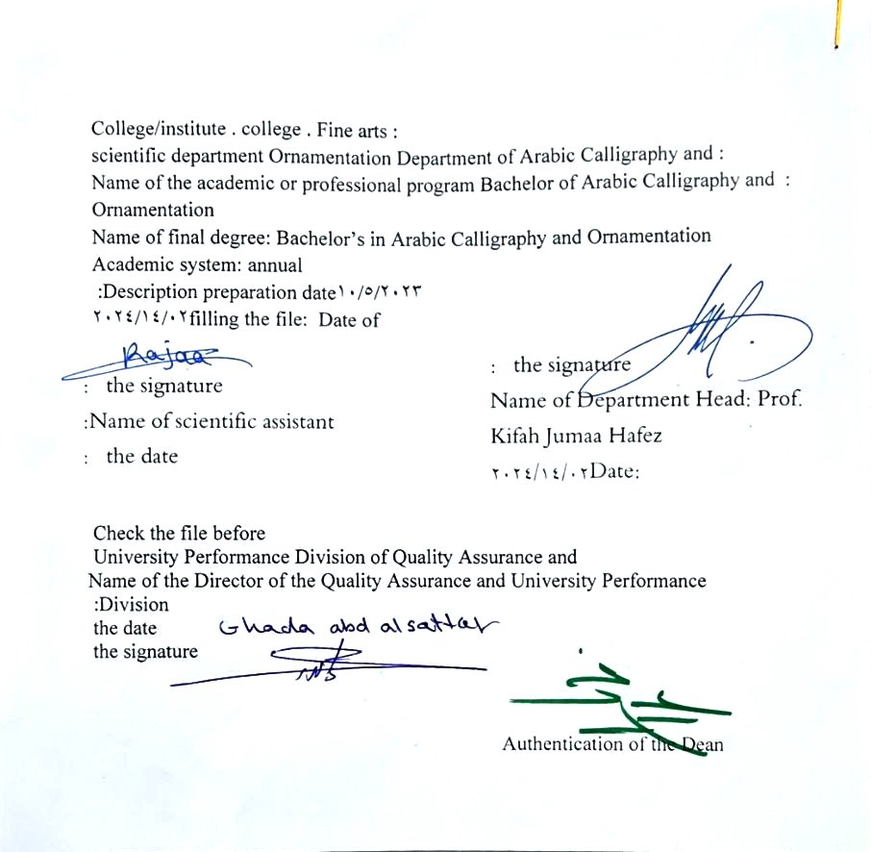

- See the program
The philosophy of the Department of Arabic Calligraphy and Ornamentation is based on achieving communication between originality and contemporaneity, communication with the living heritage of Islamic art that has not exhausted its aesthetic and applied dimensions, and communication with cultural developments that will strengthen the creative thought of the arts of Arabic calligraphy and decoration, in addition to developing scientific capabilities by developing Students’ skills in this field are enriched, through the breadth of the educational and aesthetic experience and its openness to its counterparts in other universities in the world.

- Program message
Working to prepare and graduate leading scientific and leadership competencies in languages, sciences and literature, and to develop the balance of knowledge in the field of scientific research to serve the local, regional and international community, as well as training and refining the minds of students scientifically and cognitively, and emphasizing social and cultural values and responding to the requirements of the local market.

- Program Goals
1- Preparing academic and specialized calligraphers and decorators capable of implementing and presenting artistic projects in the arts of Arabic calligraphy and decoration, to meet the needs of the relevant state departments and the labor market, who hold a bachelor’s degree in the arts of Arabic calligraphy and decoration .
. 2- Preparing specialized researchers and artists with a high level of competence in the arts of Arabic calligraphy, decoration, and its aesthetics, for the purpose of contributing to the advancement of the artistic movement in Iraq and the Arab world, on objective foundations that rely on scientific research, experimentation, and committed art through graduate students .
3- Preparing the appropriate university-academic environment and climate for students to absorb the cognitive, skillful and emotional aspects of the arts of Arabic calligraphy and decoration, through curricular and extra-curricular activities and applied research studies that highlight the Arab heritage and embody the human meanings that the fine arts carry .
4- The department’s contribution to artistic activities and research projects at the level of the University of Baghdad and other Iraqi universities and at the level of relevant institutions, unions and artistic associations, in a way that serves the artistic process, scientific progress and the growing artistic awareness in Iraqi society .
5- Providing technical consultations in the arts of Arabic calligraphy and decoration to artistic institutions locally and internationally, in a way that serves and is consistent with the objectives of the department, relevant institutions and the development movement in our dear country .

- Program accreditation
nothing

- Other external influences
nothing

- Program structure
Program structure | Number of courses | Study unit | percentage | comments *
Enterprise requirements | 9 | 16 | 22.5% | Support decision
College requirements | 6 | 12 | 15% | Support decision
Department requirements | 26 | 52 | 65% | Basic course
summer training | nothing
Other
* Notes may include whether the course is core or elective.

- Program description
Year/level | Course or course code | Name of the course or course | Credit hours
Third | G3-10 | Aesthetics | 2 | theoretical

- Expected learning outcomes of the programme
Knowledge
Informing students and making them aware of the development of aesthetics from categories to science that developed at the hands of Baumgarten and its alternating movement between idealism and materialism throughout philosophical history.
Skills
Expanding students’ perceptions and distinguishing between the ideal and material foundations of beauty with its various variations inherent in a work of art.
Value
Developing students’ abilities to share philosophical and aesthetic ideas
Disclosing one's thoughts and feelings regarding life matters, including scientific material in the beauty of the arts, including Arabic calligraphy and ornamentation.

- Teaching and learning strategies
-Explaining the scientific material through practical applications on various plastic arts, including Arabic calligraphy and decoration.
2- Write a review paper for each philosopher summarizing the most important ideas presented during the lectures .
famous aesthetic ideas with the aesthetic opinions of students .

- Evaluation methods
Weekly, monthly, daily exams and the end of the year exam.

- education institution
Faculty members
Scientific rank | Specialization |  | Special requirements/skills (if any) |  | Preparing the teaching staff
Scientific rank | general | private |  |  | angel | lecturer
Mr | 1 | 1 |  |  | 2
Assistant Professor | 1 | 5 |  |  | 6
Teacher | 2 | 1 |  |  | 3
assistant teacher |  | 3 |  |  | 3 | 2

Professional development
Orienting new faculty members
Professional development for faculty members

- Acceptance standard
A practical and theoretical test in Arabic calligraphy and decoration

- The most important sources of information about the program
- Aesthetics and its development - Dr. Najm Abdel Haider.
- History of Greek Philosophy - Youssef Karam.
- Summary of aesthetic theories - Ovsyannikov

- Program development plan
An annual change of a certain rate of up to 15% according to developments in the scientific subject.

Program skills chart
 |  |  |  | Learning outcomes required from the programme
Year / level | Course Code | Course Name | Essential or optional? | Knowledge |  |  |  | Skills |  |  |  | Value
 |  |  |  | A1​ | A2​ | A3​ | A4​ | B 1 | B2​ | B3​ | B4​ | C1​ | C 2 | C3​ | C4​
2023-2024 |  | Aesthetics | Basic |  |  |  |  |  |  | 3

- Please check the boxes corresponding to the individual learning outcomes from the program subject to evaluation

Course description form
- Course Name :
Aesthetics
- Course Code :
G3-10
- Semester / Year : Annual
Annual
- Date this description was prepared : 02/14/2024
- Available forms of attendance :
Attendance only - mandatory
- Number of study hours (total)/number of units (total):
60 hours annually . 2 An hour a week

- Name of the course administrator (if more than one name is mentioned)
Name : Prof. Dr. Jawad Abdel Kazem Farhan Email : jawad.abd@cofarts.uobaghdad.edu

- Course objectives
- Students become acquainted with the vocabulary of the subject and the development of the concept of beauty and its divisions throughout philosophical and aesthetic history.  - Students learned about the relationship between philosophy and art through this ambiguity.  - Training students to differentiate between aesthetic trends. |  |  |  |  |  | - ......  - ......  - ......
- Teaching and learning strategies
The strategy |  | 1- Educational strategy, collaborative concept planning.  2- Brainstorming education strategy.  3- Education Strategy Notes Series
- Course structure
the week | hours |  | Required learning outcomes | Name of the unit or topic |  |  | Learning method | Evaluation method
1  2  3  4  5  6  7  8  9  10  11  12  13  14  15  vacation  16  17  18  19  19  20  21  22  23  24  25  26  27  28  29  30 | 2 hour  2 hour  2 hour  2 hour  2 hour  2 hour  2 hour  2 hour  2 hour  2 hour  2 hour  2 hour  2 hour  2 hour  2 hours  2 hours  2 hour  2 hour  2 hour  2 hour  2 hour  2 hour  2 hour  2 hour  2 hour  2 hours  2 hour  2 hour  2 hour  2 hour  2 hour |  | 1- Providing students with the skill of detailed knowledge of the development of science and aesthetics throughout philosophical history.  2- Informing students about the importance of aesthetic theories in different eras. | Introduction to aesthetics  Presentation of aesthetic concepts  Beauty among the Stoics  Beauty according to the Pythagoreans  The Sophists' view of beauty  Aesthetic concepts and opinions according to Socrates  Beauty according to Plato  Aristotle's aesthetic concepts  Exam  Illuminationist philosophy  Plotinus' theory of emanation  Islamic philosophy  Beauty according to Al-Farabi  Beauty and art according to Ibn Sina  The porter in Al-Kindi’s perception  First semester exam  Al-Ghazali's aesthetic views  Beauty and art according to Abu Hayyan Al-Tawhidi  Beauty according to Ibn Rushd  Modern idealist philosophy  Descartes' aesthetic philosophy  Opinions were about beauty  Hegel's aesthetic vision  Exam  Schopenhauer's aesthetic vision  Bergson's aesthetic  Croce's aesthetic views  Marxist aesthetics  Pragmatic aesthetics  Existential aesthetics  End of year exam |  |  | Explaining the scientific material by introducing the general frameworks of each philosopher’s theory, and then his aesthetic visions that fall into the category of idealism or materialism, their divisions, and their relationship in artistic embodiment. | Weekly, monthly, daily, written exams, and the end-of-year exam .
- Course evaluation
Distribution is as follows : 25 marks for monthly and daily exams for the first semester . 25 marks for monthly and daily exams for the second semester . 50 marks for final exams
- Learning and teaching resources
Required textbooks (methodology, if any) |  |  |  |  | Aesthetics and its development prospects - Dr. Najm Abdel Haider
Main references (sources) |  |  |  |  | Summary of aesthetic theories  Aesthetic values - Rawya Abbas  History of Greek philosophy
Recommended supporting books and references (scientific journals, reports....) |  |  |  |  | Symbolic beauty - Hegel  The Faculty of Aesthetics - Dr. Jawad Al-Zaidi
Electronic references, Internet sites |  |  |  |  | Websites on aesthetics and philosophy

